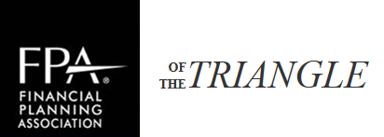
2018 Corporate Sponsorship Levels
 | PLATINUM SPONSOR  $3,000 | GOLD SPONSOR  $1,500 | SILVER SPONSOR  $500
Full-Day Symposium
October 11, 2018
Skirted table for display of promo materials & Complete list of the 75-100 attendees
Monthly Meetings
5 mins to deliver presentation & Complete list of the 40-50 attendees
Special Thank You
Recognized in the meeting announcements for the event(s) you sponsor
Website Recognition
Sponsorship recognition on www.fpatriangle.org with link to your company’s website
Preferred Meeting Guests
Attend all chapter monthly educational meetings (limit 5 reps)
Chapter Event Exposure
Send promo materials to all chapter events
Ethics Program
March 8, 2018
Skirted table for display of promo materials & Complete list of the 60-75 attendees
Monthly Meeting Speaker*
Event Speaker
Speaking time of 3 mins at the beginning of:
Ethics Program, March 8
Symposium, October 11
Annual Education Symposium Speaker**
October 11, 2018

*Presentation must align with the agenda and qualify for CFP® CE. Practice Management topics will be considered if meets the needs of membership. Program cannot be product or company specific. Limit 2 per year.
** Presentation must align with the agenda and qualify for CFP® and General Insurance CE. Limit 3 per year.

