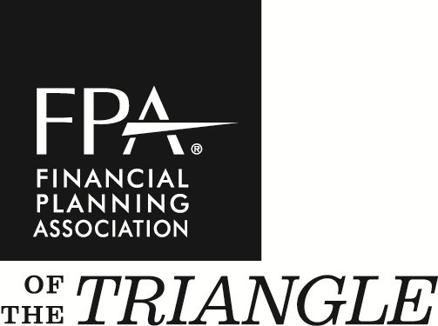

919-260-7709
president@fpatriangle.org
3801 Lake Boone Trail, Suite 190
Raleigh, NC 27607
www.fpatriangle.org

December 31, 2018

Dear FPA-of-the-Triangle Chapter Members,

As we approach the end of a very busy year, I would like to take this time to thank all of you for your involvement with our chapter, and your commitment to make this chapter better, while improving your own business.

The theme of this year is community engagement. We will do our best to provide you with the content you need to help you grow your business. The FPA has also announced their initiative to create a unified organization. We will do our best to relay information to you as soon as we get it relating to the changes they plan to make in 2019 and beyond. We will be making some local changes as well, so be sure to attend the meeting in January to hear all about it!

We had success introducing GoToWebinar at some of our chapter meetings last year. We are excited to announce that all chapter meetings this year will be broadcast via GoToWebinar. We believe this will increase the value that FPA of the Triangle provides to our members. This is not to stop you from coming to chapter meetings, but to encourage more of the members who are unable to get to Raleigh to participate and provide valuable input. Stay tuned for future updates to our virtual presence.

Please take a few moments to add the chapter meeting dates to your calendar and get yourself ready for a great year.

On behalf of the Board of Directors, we look forward to meeting you and shaking your hand at our next chapter meeting in January.

Have a joyous holiday and a happy and prosperous New Year!

Sincerely,

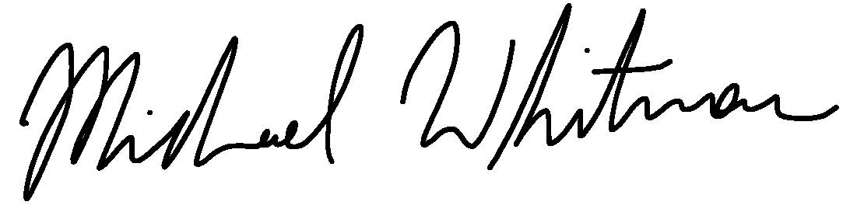

Michael Whitman
President 2019

2019 Board of directors

PRESIDENT
MICHAEL WHITMAN, MBA
MILLENNIUM PLANNING GROUP

BOARD CHAIR
THOMAS SCHAFFER, LUTCF
NEW YORK LIFE

PRESIDENT-ELECT
WAYNE TILLMAN, CRPC
INSIGHT PRIVATE ADVISORS

SECRETARY/TREASURER
JANETTE PEREZ, CPA, CFP®

PROGRAMS DIRECTOR
ADAM WHITESELL
AMERIPRISE FINANCIAL

CORPORATE SPONSORSHIP DIRECTOR
ADAM WHITESELL
AMERIPRISE FINANCIAL

MEMBERSHIP DIRECTOR
WAYNE TILLMAN, CRPC
INSIGHT PRIVATE ADVISORS

NEXGEN DIRECTOR
IAN BLOOM, CFP®
OPEN WORLD FINANCIAL GROUP

COMMUNICATIONS DIRECTOR
HALEY TOLITSKY
COOKE CAPITAL LLC

MEMBER AT LARGE
CHRIS HOSTETLER, CFP®, CFPS®
HILLTOP WEALTH ADVISORS

CHAPTER EXECUTIVE
MEGAN COLLIER
Mission
Our mission is to serve our members through education, professional development, networking and advocacy.
Vision
The FPA of the Triangle is the preeminent organization for all financial professionals. The FPA of the Triangle provides a forum for continuing education, career development, and active networking while adhering to the highest ethical standards.

