Seventy Four percent of Social Security recipients are taking early retirement benefits. Many of those people may have made a serious financial mistake. Some of them can correct it. Election strategies combined with income tax planning may make hundreds of thousands of dollars of difference to your clients over their lifetimes. The Supreme Court decision in Obergefell v. Hodges has made a significant change in the landscape of Social Security claiming decisions. This outline covers some of the issues that

Social Security Optimization and Retirement Income Planning
David A. Cechanowicz JD, MSFS, ChFC, CLU
Social Security Timing

Sponsored by:
FPA of Greater Indiana

1

Demographics and Current Research

  - 1.1 Introduction
The claiming of Social Security (SS) benefits may be the most important retirement income decision facing today’s baby boomers. While software tools have been developed to help advisors explain claiming strategies, many important retirement income planning issues seem to get lost or overlooked in the rush to explain a solution that only appears to be simple.
The SS claiming decision involves a complex interaction of different components across three primary planning areas. It is the integration of planning for retirement income across the following three sectors that we hope to emphasize.
Risk Management: Including the issues of mortality and morbidity, long-term care planning issues, and the general risk of out-living one's retirement income.
Income Taxation: In some cases clients may see significant reductions in income taxation depending on how their retirement income is structured. Those benefits may come close to equaling the additional annual revenue that can be obtained from delayed Social Security claiming. Much of the recent press that you may have seen regarding SS claiming frequently ignores the issue of income tax planning.
Portfolio Management: How much a client has invested as well as how those investments are structured can have a significant impact on the entire retirement income planning process. Since delayed SS claiming will increase foundational income, pressure on a client’s investment portfolio may be reduced. Conversely, delaying SS benefits may create an income gap that has to be funded during the delay period. Funding those gap years becomes a significant issue for clients who may not have accumulated sufficient retirement assets.
It is the balancing of these forces that converts the claiming decisions from what appears to be science into art. Each client situation is unique and there may be slight changes in the claiming decision that may give a client more psychological comfort than might be suggested by the highest lifetime benefit. We will attempt to address those planning issues in this course.
  - 1.2. Dual Income
The dual income family consists of the following:
Married – with two workers in the family
Single worker, married for 10 years, now divorced.
Widow / Widower worker, previously married to a worker
  - 1.3. Demographic Issues
We have all seen the figures of how 10,000 baby boomers are retiring every day. Behind those numbers are these additional facts:
- Target market: age 58 to 66
- Amount of people having a birthday every day: 90,000
- Total group size: 32,850,000
Special Issue – Dynamic of the Group – The Marshmallow Test
In the late 60s to early 70s, a professor at Stanford University conducted a series of experiments with young children focusing on issues of delayed gratification. Those tests have become known as the marshmallow tests. The test was designed to see if a child could resist eating a marshmallow placed in front of him or her, in favor of having 2 marshmallows to eat after a wait of approximately 20 minutes.

Two thirds of the children could not wait for the second marshmallow. Follow-up studies were done on the children that waited, and those children tended to have better life outcomes as measured by things such as “SAT scores, educational attainment, body mass index, and other measures.”

  - Relationship to Social Security Claiming
There is no direct link from the Marshmallow test to any claiming patterns for Social Security recipients. However, Social Security statistics show that approximately 74% of current recipients claimed their benefits prior to full retirement age.

Additionally, those same statistics show that approximately 2/3 of all Social Security recipients do not pay any Federal income taxes.

  - Bell Curve Distribution
Extrapolating from the early claiming data, if we assume 70% of current retirees will claim early, then the remainder represents a premium subset of our target market.

This group equals 9 million people.
They represent 3.12% of the United States population.
This means that there could be approximately 3,000+ potential claimants per 100,000 people in your marketplace.

This particular group offers two important planning possibilities to financial advisors.

First, at the far end of the spectrum are the high net worth to ultra-high net worth investors that are sought after by many financial advisors. They represent approximately half of the premium group.
Secondly, the other 15 percent represents a group that can probably benefit the most from the benefits of income tax planning that will created higher net incomes for them. We will address those issues later this afternoon.

1.4 Research into the Demographic
  - 2012 Federal Reserve Study
In March of 2013 the Board of Governors of the Federal Reserve released a study conducted by a staff economist, Alice M. Henriquez. It examines the theory that families make Social Security claiming decisions based on what is best for the family as opposed to the individual.

The abstract for the study notes that “a majority of women receive most of their Social Security benefits based on their husbands’ earning record.”³ To examine the effect of claiming decisions on total lifetime household income, it examined the claiming records of 13,753 men. Several of the findings are of special interest:

- Almost half of the men claimed as soon as possible at age 62.
- The second spike in claiming occurred at age 65 with only 5% claiming after age 65.
- The study cites the fact that a primary reason for the lack of delayed claiming was the “less than fair delayed credit (DRC) for the older cohorts.”⁴
  - Study Conclusions
- Wives are dependent on their husbands for Social Security Benefits, “a situation that persists even after the dramatic increase in labor force participation and wages women have experienced over the past several decades.”⁵
- “Husbands are very responsive to their own benefit incentives, but they are not responsive to the incentives created by dependent benefits.”⁶
- The fact that husbands fail to respond to spousal and survivor incentives can significantly reduce wives’ lifetime Social Security benefits.
- Most families do not maximize benefits for the household lifetime.
Social Security Timing Research
Social Security Timing® has run over 100,000 reports since 2013. Following is a summary of major conclusions drawn from our data:

- Average age difference: 3 Years
- Average ages: male 62 – female 59
- The present value difference between the early and suggested strategy equals approximately $150,000.

  - Why your clients are different
First of all, the markets that you will most likely be targeting have access to significantly higher delayed retirement credits (DRCs) Previous delayed retirement credits started at 1% and over a period of years legislation was introduced increasing to 3% and then all the way up to 7% for the age group at the end of the Federal Reserve Study.

Secondly, many of them are higher wage earners than the general population. As such many of them have higher life expectancies.

2

Social Security Claiming Basics

Core Facts, Eligibility, Benefits – Primary Insurance Amount – Average Indexed Monthly Earnings, Full Retirement Age, Early Retirement, Delayed Retirement Credits
  - 2.1 Longevity issues
- Core Facts
  - 74% of those collecting Social Security Retirement benefits are receiving reduced amounts.
    - 76.4% of women
    - 71.4% of men
  - Beneficiaries over age 85 have increased by 23% in the last 10 years
    - 4.0 Million 2000
    - 5.2 Million 2010
  - Greatest percentage increase in those aged 95 and older – 26%
    - 304,000 in 2000
    - 413,000 in 2010
  - Over 51,000 centenarians collected SS benefits in 2010
    - Represents an increase of over 10,000 in 10 years
  - Fifty Seven percent of SS recipients age 62 and older are women.
    - That number rises to 68 percent at age 85

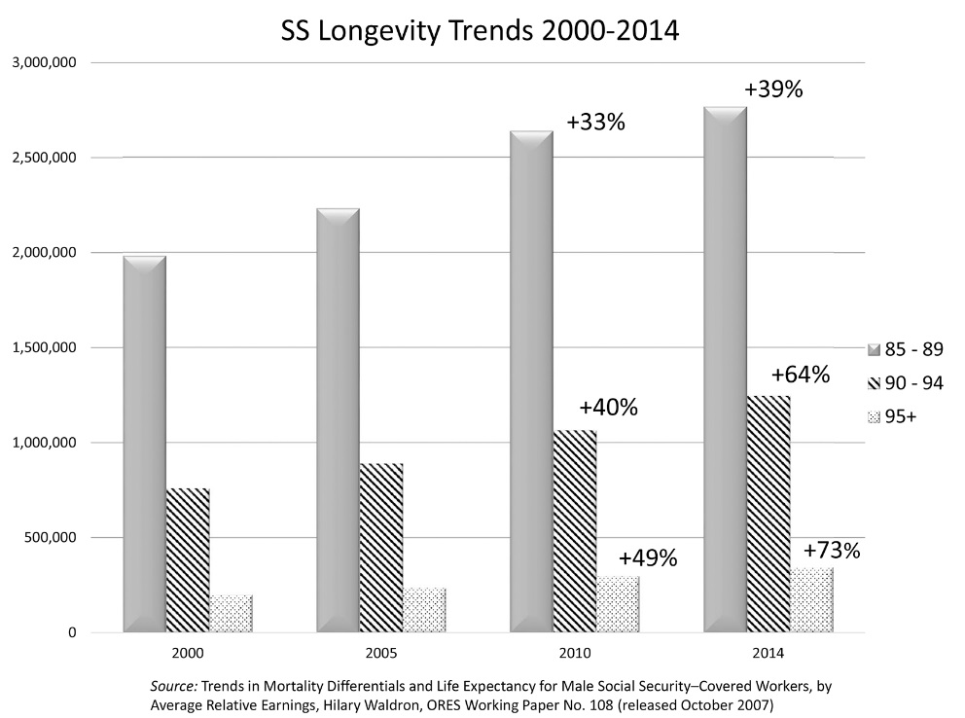
Significant changes in longevity of older aged claimants can be seen in just the last 4 years. The numbers in red represent percentages from 2000 – 2010 and the last columns represent the changes from 2000 – 2014.
Additionally, although the SSA claims that total early claimants as a percentage have been running between 73 and 74 percent for the last 12 or 13 years, when adjusted for disability claimants that are included in the totals, the recent numbers have been at least 10 percent higher. Recently however, adjusted claim levels have shown a significant drop so that they are closer to the published “pooled” rate.

  - 2.2 How are benefits determined?
- Social Security Primary Insurance Amount – What is it?
  - Defined: The benefit (before rounding down to the next lower whole dollar) a person would receive if he/she elects to begin receiving retirement benefits at his/her normal retirement age.
  - Average Indexed Monthly Earnings
    - Social Security benefits are computed using “average indexed monthly earnings.” The average is a summary of up to 35 years of a worker’s indexed earnings. A formula is applied to the average to compute the primary insurance amount or PIA.
    - The PIA is the basis for the benefits that are paid to an individual.
  - Essentially it’s a defined benefit formula that has an inflation adjustment built in that considers your highest 35 years of earnings.
- What are the bend points that make up the calculation of the Average Indexed Monthly Earnings?
  - The PIA is the sum of three separate percentages of portions of average indexed monthly earnings, or said another way; your benefit is calculated as a percentage of three separate chunks of money.
  - The first step in the calculation is to convert all of the beneficiary’s wages to “indexed” wages according to set conversion factors for each year.
  - Then the highest 35 years are added together.
  - Next, the result is divided by 420 to arrive at the claimant’s Average Indexed Monthly Earnings. (AIME)
  - Once the AIME is computed, credits are by differing amounts based on a three tiered calculation. Each time the calculation level changes, SSA refers to that point in the calculation formula as a “bend point.”
  - For 2015, the bend points are the first $826, the amount between $826 and $4,980, and the amount over $4,980.
  - The formula for 2015 is calculated as follows:
    - 90 percent of the first $826 of his/her average indexed monthly earnings, plus
    - 32 percent of his/her average indexed monthly earnings over $826 and through $4,980, plus
    - 15 percent of his/her average indexed monthly earnings over $4,980.
  - Compare to earlier bend points:
    - 1979 – 180.00 / mo. was the 90% point.
    - From 180 to $1,085 / mo. was the 32% bend point.
  - Why is this important
    - As a planning point for dual income boomers – it may be worth considering adding a lower paid worker to the payroll up to the 90% bend point.
  - 2.3 Changes to Full Retirement Age
- Full Retirement Age – (FRA) what is it and what is the significance?
  - FRA is that point in time when a person is eligible for his full retirement benefit based on his / her PIA.
  - That age is a moving target – based on the year of birth:
    - 1937 or Earlier – Age 65
    - 1938-1942 – Add 2 months per year
    - 1943-1954 – Age 66
    - 1955-1959 – Add 2 months per year to 66
    - 1960 and later – Age 67

  - 2.4 Mortality and Social Security Claiming
As a group, American retirees and pre retirees have been labeled “clueless” about their own mortality and the effect that inadequate expectations will have on their retirement planning. Additionally, a recent study found that more than half of Americans underestimate their life expectancy, and as a consequence have financial planning horizons that are too short.
It is critical that financial and retirement planning advisors assist their clients in understanding the pitfalls of under estimating the planning horizons that they need to consider. With the high percentages of claimants claiming early retirement benefits, it is apparent that many of them may have made a significant financial mistake that will endure possibly for decades.
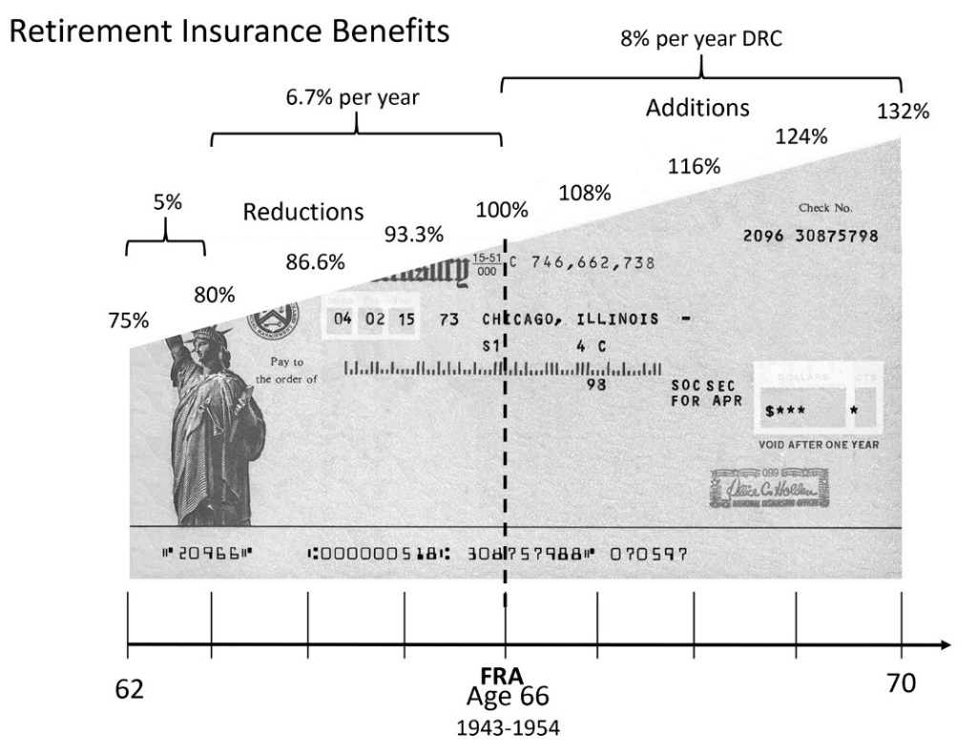
  - 2.5 Basics of Claiming Social Security Retirement Benefits
  - 2.6 Collection of Spousal Benefits
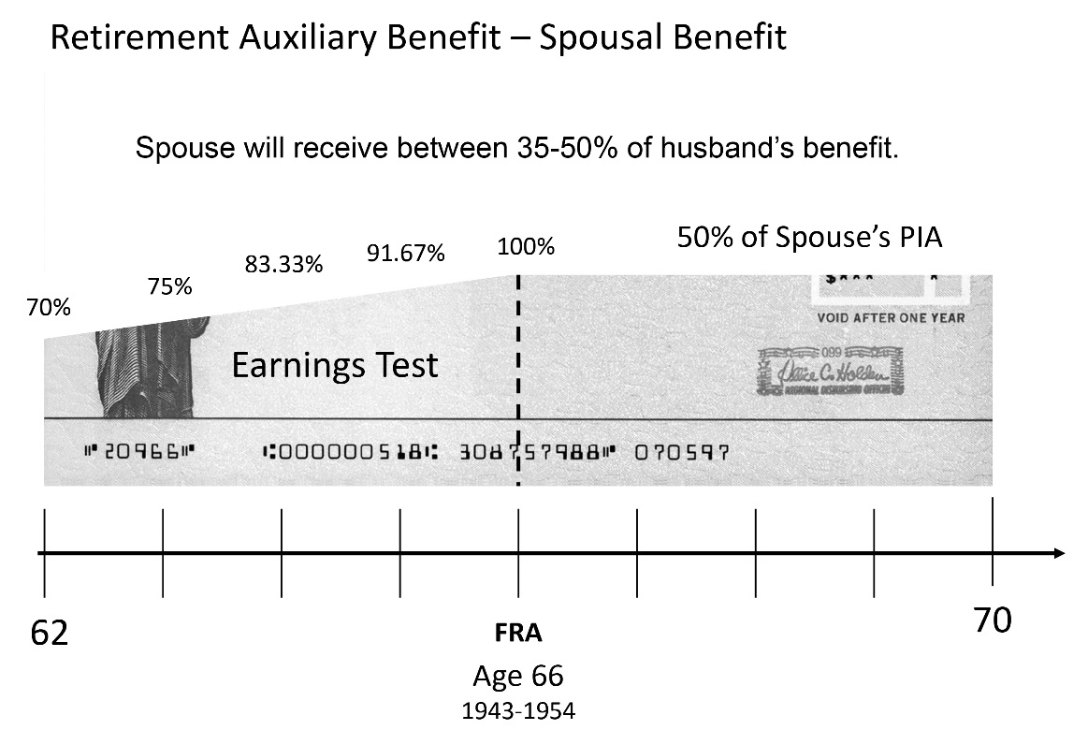

  - 2.7 Spouses and Widow(er)s
The Social Security program was established at a time when it was normal that one member of the family was the wage earner. Over time, since the majority of women did not have a work history, spousal benefits were added for them. Those benefits were capped at one half of the worker’s retirement benefit.
Spousal benefits are available as an auxiliary benefit for those beneficiaries who have been married for at least one year.
Generally, the spouse must not qualify for a benefit of their own that is equal to or greater than ½ of the primary workers Primary Insurance Amount (PIA).
The spouse benefit is capped at ½ of the workers Primary Insurance Amount.
The benefit is reduced for claiming prior to full retirement age (FRA), but on a schedule that is different than reductions for early retirement benefits on one’s own work record.
Reductions for early filing on spousal benefits are greater than reductions for benefits related to the workers own retirement benefit.

General Issues
- Due two benefits?
  - Get the higher amount
- Most working spouses get more on their own SS at retirement than they do on their marriage partner’s record while (s)he’s still living
- But when spouse dies – the widow(er) rate is normally more than his or her own retirement
- Unmarried, divorced spouses married 10 years or more are also due benefit on their ex’s record.

Spouse Benefits
- Available starting at the age of 62
- Maximum of 50% of the Number Holder’s PIA at Full Retirement age
- Reductions for early claiming reduce the spousal benefit to 30% of the PIA at age 62.

  - Spousal Benefits Summary

- Spousal benefits cannot be more than 50% of the wage earners PIA.
- If the wage earner waits to collect beyond FRA, it does not increase the spouse benefit.
- In a dual income situation only one spouse can claim spousal benefits at any point in time. There is no such thing as cross claiming for married couples.
- NOTE: No spousal benefits are available unless the worker has already filed for his or her benefits. A spouse that has filed and suspended benefits still counts as a spouse that has filed for benefits. The new changes in Social Security legislation will remove the ability of a spouse to collect a benefit on a suspended claim.
  - 2.8 Relationship between Early and Late Claiming
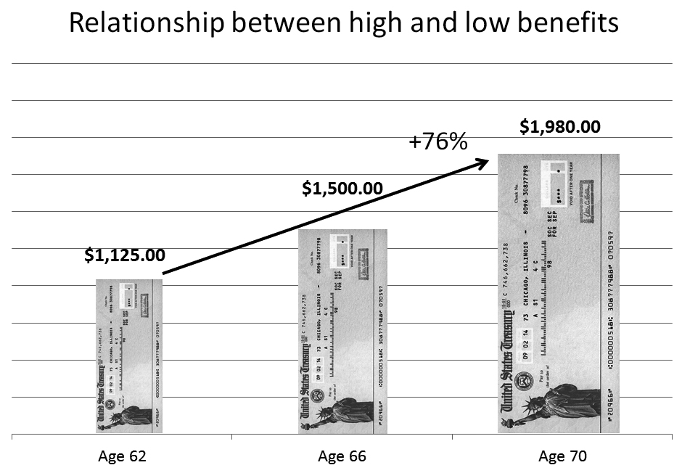
  - 2.9 Choosing a Strategy / Combining Benefits
Opportunities for dual income claiming
In the dual income or former dual income situation, the claiming strategy should center on the ability of a worker to claim one retirement benefit, and then switch to another benefit at a later date.
What makes switch strategies possible?
- Voluntary Suspension – This allows an individual the ability to file, and then request that checks be stopped. During the period in which no checks are received, the NH (number holder) will continue to earn delayed credits.
- Restricted Application - Allows an individual to limit an application to only one benefit, which may allow another benefit to receive delayed credits.
For example, I limit my application for benefits to only my spouse benefit. This allows my retirement benefit to earn delayed retirement credits.
- MAJOR POINT – DEEMING applies to Retirement cases – NO switching prior to FRA (widow cases are an exception).
The core issue when considering the combination of strategies is to look to the present value of all a family benefits, rather than the breakeven point for one or both people as individuals.
Review of Deeming Provision for Retirement Income Claiming
Prior to full retirement age the Social Security Administration deems that when you file for retirement benefits you file for all benefits. For example if a spouse attempted to claim only spousal benefits prior to full retirement age, she would be deemed to be filing for her own retirement benefits as well.
It is impossible to file for only spousal benefits prior to full retirement age, unless you do not qualify for a worker’s benefit. As a result, early retirement claiming means that both spousal and workers retirement benefits would be claimed. All benefits for which the recipient is eligible will be claimed.
Full Retirement Age and the Deeming Provision – Old Law
Once a worker reaches full retirement age, the deeming provision no longer applies. At this point in time, the worker is free to file for either a spousal benefit or a retirement benefits without claiming both benefits.
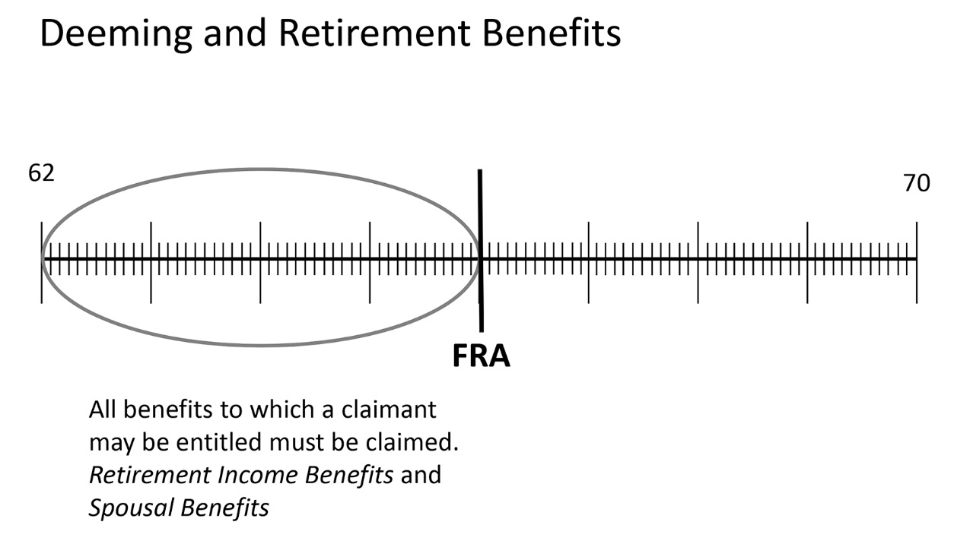
Voluntary suspension of Benefits
Retirement income benefits may only be suspended when the recipient reaches full retirement age. This enables several planning options for the worker who elects to suspend benefits.
- Voluntary suspension at FRA enables another beneficiary the ability to collect a spousal or family benefit on the record of the person suspending the benefit. As we will see later, this benefit will most often benefit the spouse of the worker.
- Voluntary suspension is an option for a disabled worker to accumulate Delayed Retirement Credits after the benefit automatically switches to the Retirement Income Benefit at FRA. However, this is the only option for the disabled. At this time, filing a restricted application for spousal benefits at FRA is not available.
- Voluntary suspension could also be used by a worker that had to collect early and then found financial circumstances changed that would enable him or her to stop working after FRA. DRCs would be added to the worker’s benefit at the rate of 8% per year.

Stopping and restarting benefits
- As explained in section c. above, a worker could be claiming benefits and then stop those benefits at FRA (or later) and then restart them at a later date. Delayed retirement credits would be earned for the period when benefits were stopped.

2.10 2015 Budget Act Changes to the Law
Introduction
The Budget Act of 2015 was negotiated in just a few days and shortly afterward it was signed into law on November 2, 2015. The Act introduced monumental changes to the strategies that have been promoted to and used by our clients over the past several years. We believe that the confusion and complexity introduced by the act will persist into the future and will result in planning and marketing opportunities for those who will dig in and understand how the new law affects retirement income planning.

The overall focus of the change was directed at those claiming strategies that we identify as Switch Strategies.® In the dual income or former dual income situation, the Switch Strategy centers on the ability of a worker to claim one retirement benefit such as a spousal benefit, and then switch to another benefit at a later date.

There are two foundational principles that allow for the Switch Strategy® to work, the ability to file and suspend benefits and the ability to file a restricted application for a benefit. The blending of these two principles allowed a Social Security recipient to file for one retirement benefit and switch to another benefit in the future. Generally, a wage earner would file for his or her benefits and then suspend those benefits so that another auxiliary beneficiary such as a spouse or child could claim benefits. During the period of suspension, the primary account holder’s primary insurance amount (PIA) continued to earn delayed retirement credits (DRCs).

2.11 Changes to Voluntary Suspension of Benefits
The new law prohibits:
any individual from receiving retroactive benefits for a period of voluntary suspension.
any individual from receiving benefits based on the earnings of an individual who has suspended his or her benefits, during the period of suspension; and
an individual whose benefits are suspended from receiving benefits on any other record, during the period of suspension.
We will look at each of these items in depth in the following section.
Retroactive Benefits:
The new law eliminated the ability for an individual to file and suspend at full retirement age and then retroactively claim benefits back to the time of suspension at a future date. While this provision was available to everyone, it was primarily marketed as a strategy for singles because if a married individual exercised this provision it would reduce survivor benefits. Single individuals that suspended and then had a significant health or financial crisis had the ability to rescind their suspension and claim a lump sum retroactive benefit. The retroactive claim is not prohibited effective with suspensions after April 29, 2016.
Benefits to Auxiliary Beneficiaries
This provision eliminates the ability of an auxiliary beneficiary to claim a benefit while a claim is suspended. Generally, this law will apply to spouses and children of the insured individual. The elimination of auxiliary benefits on a suspended claim creates a tension between the needs of auxiliary beneficiaries and between the future benefits available to auxiliary beneficiaries.
For example, if a high earner wishes to delay the claiming of their benefit so as to insure a larger survivor benefit, that delay will also eliminate the ability to provide a spousal benefit during the delay period. Additionally, in those situations where the insured individual has both a spouse and young children, this provision creates requires the insured to choose between the current needs of children against the future needs of a surviving spouse. We will explore this dynamic in a case study in the following sections.
Prohibition from claiming benefits while in suspension
The third prohibited action involves a claiming strategy that we recommended if the circumstances were right. First, the individual in question was generally the low wage earner who had filed early. Second, the low wage earner may or may not have also filed for spousal benefits, depending if they were available. Finally, after reaching full retirement age (FRA) the low wage earner would suspend their own work record. The suspension would enable delayed retirement credits to offset the effect of the early claim and spousal benefits would continue to be paid (if available).

The new law eliminates the ability for this strategy to be exercised and is effective for any suspensions filed after April 29, 2016.

Effective date of the Voluntary Suspension Changes
The law created a 179 day window of opportunity for select group of individuals to exercise the old file and suspend strategies through April 29, 2016. That group is limited those individuals who have already reached FRA or will turn 66 years old by May 1, 2016. On April 30, 2016 the new law is effective for all claims that voluntarily suspend benefits.

2.12 Changes in the Law regarding the Restricted Application
Prior to the enactment of the Budget Act of 2015 the ability to file a restricted application for benefits was coupled to the concept of deeming. The principal of deeming pivoted around the claimant’s Full Retirement Age. Prior to FRA all claimants were deemed to have claimed all the benefits for which they were eligible, both their own Retirement Insurance Benefit (RIB) and their spousal benefit if they were eligible for one.

After Full Retirement age, an individual was able to choose which benefit he or she would claim first. Generally, one would claim a spousal benefit while allowing the Retirement Insurance Benefit to accumulate delayed retirement credits. This strategy was frequently implemented to enable the higher wage earner to delay his or her retirement benefits and collect the delayed retirement credits. One of the benefits of this strategy is that delaying the filing of a RIB would generally meant that survivor benefits would be increased for the family, usually the surviving spouse, but in some cases for young children as well.

The new law eliminates FRA as the pivot point and states that all claimants are always deemed to be filing for all benefits for which they are eligible. The law also provides that any benefit that becomes eligible after the initial claim must be paid in the month following the month of eligibility. For example, if a worker in a dual income family files for his or her retirement benefit and is not yet eligible for a spousal benefit because the spouse has not yet filed, at the time the spouse files, eligibility is created and benefits must be paid.

Who the Law Affects
The changes in the law with respect to deeming are effective for individuals who attain age 62 after December 31, 2015. Because of a quirk in the way that the SSA computes birthdays, this includes all individuals who were born after January 2, 1954.

2.13 Timeline of Claiming Changes
The following chart illustrates the three groups of individuals that are affected by the changes. As an example, the provision in the law that broadened the deeming provision that will eliminate restricted applications will apply to everyone who “attains age 62 in any calendar year after 2015.” For practical purposes, the law allows for anyone who is 62 years or older to file a restricted application. However, the application of the law will apply for a limited period of time and will not affect immediate claiming for most of the individuals who have not yet claimed their benefits and have reached full retirement age.
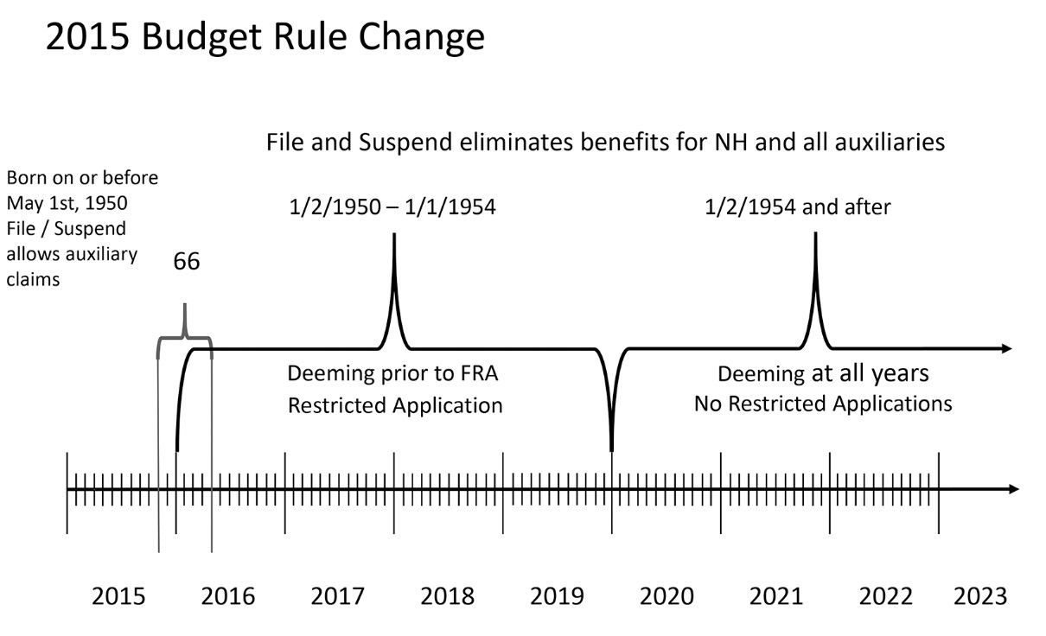
Those who turned 62 prior to January 2, 2016 will still have the ability to restrict their claims to a spousal benefits provided one of two conditions are met. The first group of individuals will be able to claim restricted benefits if their spouses qualified for and filed for Voluntary Suspension prior to April 30, 2019. For the second group, the claimant must have reached full retirement age (FRA) and additionally, their spouse must have filed for his or her own benefits.

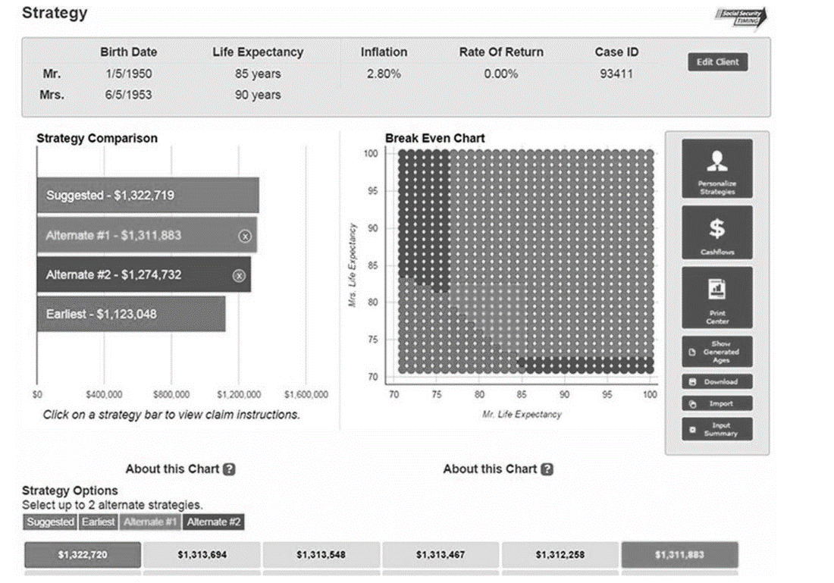
  - 3.0
  - Claiming Options
The primary issues that clients need to consider in order to properly claim their benefits go beyond the basic inputs for a claiming optimizer. Clients need to seriously consider the following:
- Issues surrounding employment, their needs, and ability to find work.
- Financial needs as compared to wants, and whether or not there is latitude to make adjustments.
- The amount of retirement savings, or ability to continue to save.
- The composition of their portfolio.
- Their health and longevity
- Their attitudes relative to solvency issues surrounding Social Security
- Their ability to defer gratification (Marshmallow Quotient)
  - 3.1 The breakdown of breakeven analysis
Traditional break even analysis relative to Social Security claiming generally includes the following:
- Assumption that funds are not needed till a later date and invested, not consumed.
- Invested amounts are compounded at a given rate of return
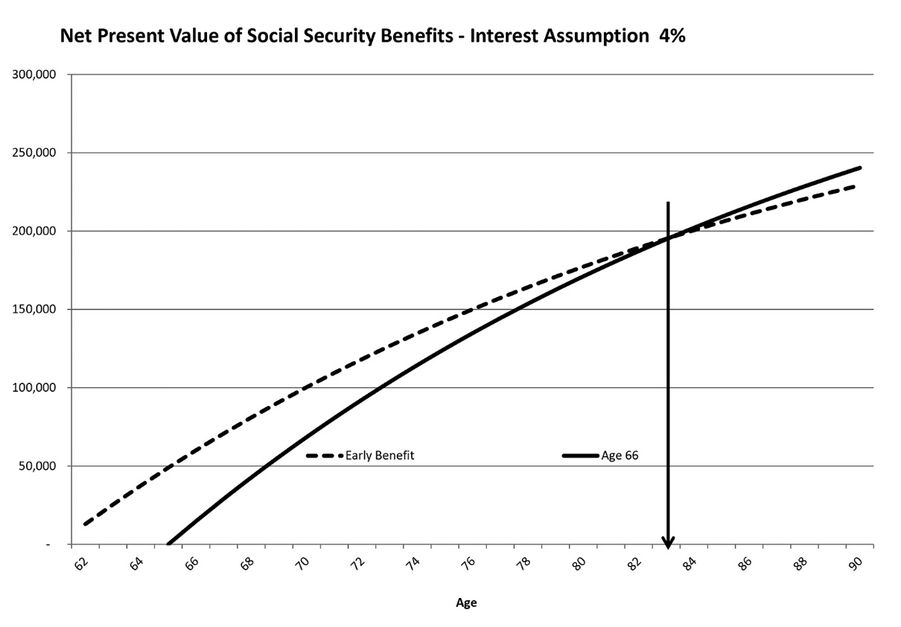
- “Cross-over” point graphed as to how long a person needs to live in order to break even, and pull ahead in terms of net benefits
The breakeven analysis works fine for single individuals, but it fails to address all of the issues that surround claiming for a dual income or former dual income couple. Those issues are:
  - 3.2 Planning options for the dual income couple
Summary of Several Planning Options for a Dual Income Couple
  - Jill, – Age 62 – PIA 900.00 month
  - Ron, Age 66 – PIA $2,400 month
  - Cola Assumption 1.5%, ROR 1%
  - Traditional higher earner low earner family situation

Nine Planning Options:
- Both early 62 / 65
- Both at their FRA 66 / 66
- Both late 70 / 70
- High early, low at FRA
- Low early, high late
- High at FRA, low early
- Low at FRA, high late
- Low at FRA plus spousal, high files and suspends
- Low early plus spousal benefit, high restricted, then high late

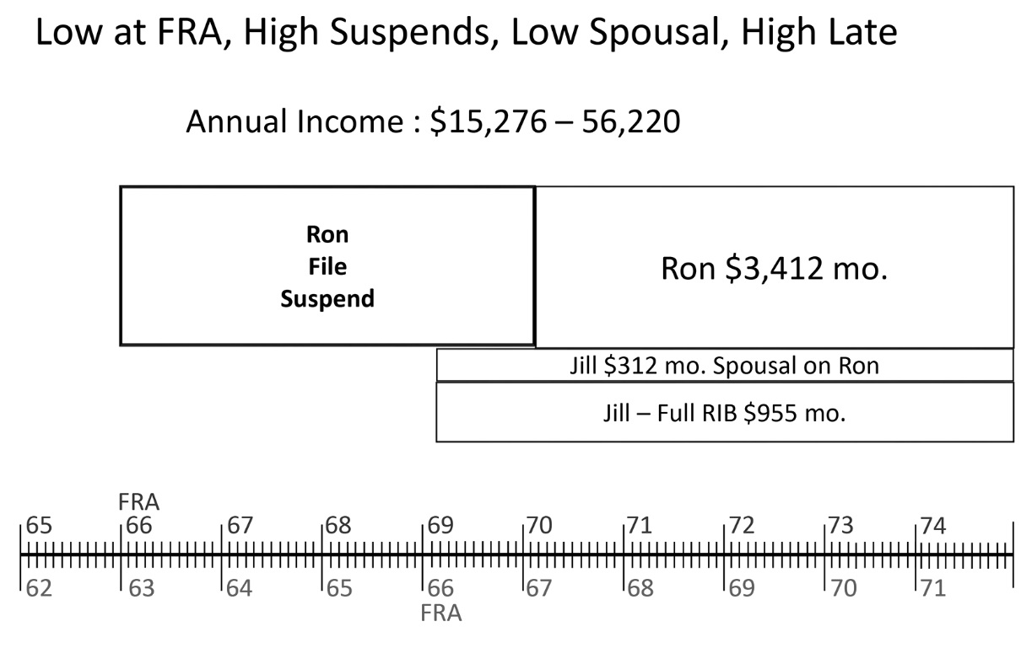
Scenario h:

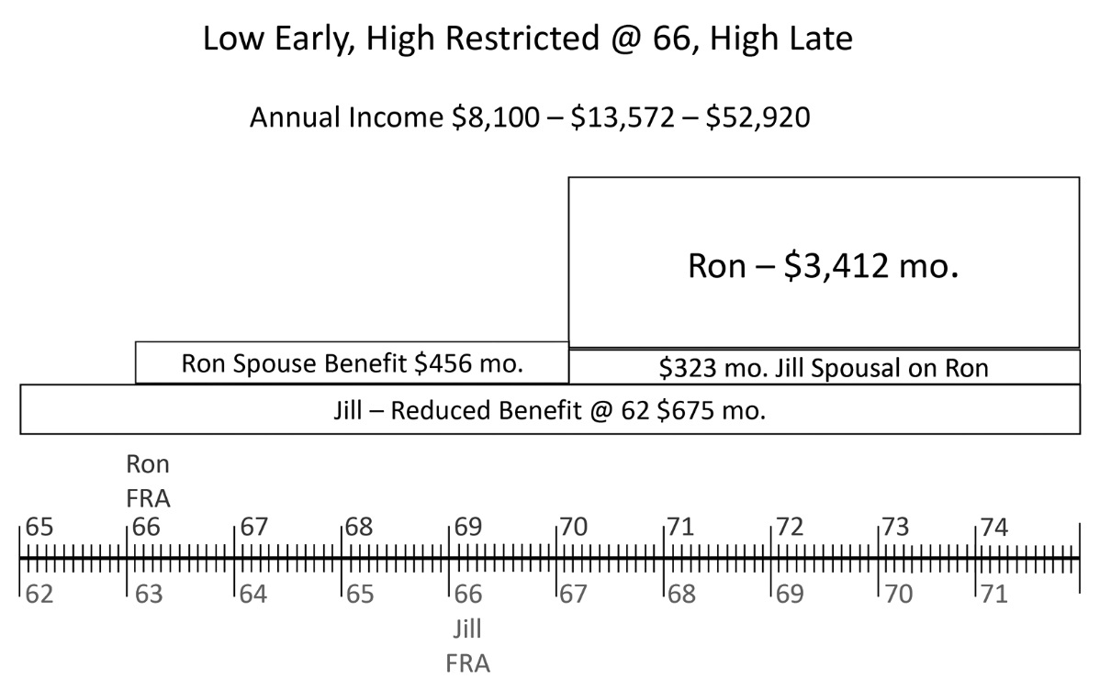
Scenario i:

Ron and Jill PV comparison
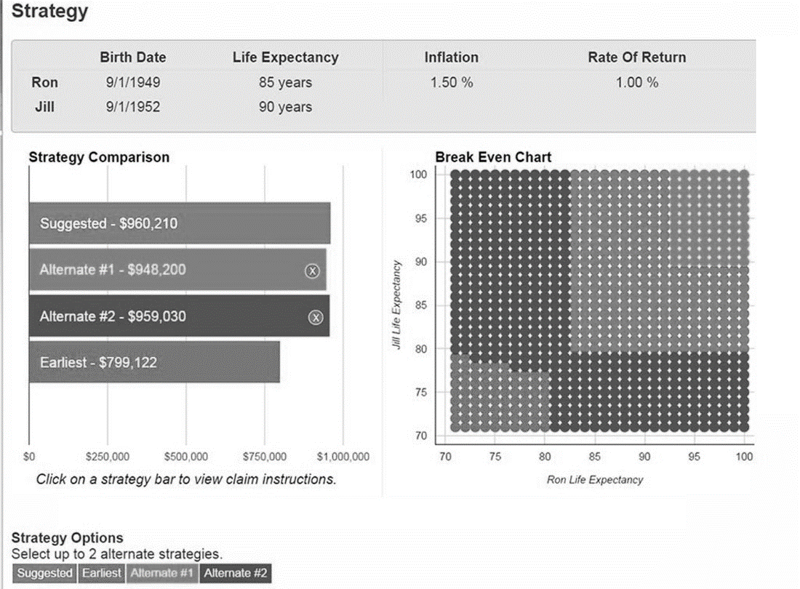
  - 4.0
  - Taxation and Social Security Benefits
  - 4.1 Basics
2016 Federal Ordinary Income Tax Rates | Single | Married Filing Joint | Head of Household
Personal Exemption | $4,050 | $4,050 | $4,050
Std. Deduction | $6,300 | $12,600 | $9,300
10% | $0 – $9,275 | $0 – $18,550 | $0 – $13,250
15% | $9,276 – $37,650 | $18,551 – $75,300 | $13,151 – $50,400
25% | $37,651 – $91,150 | $75,301 – $151,900 | $50,401 – $130,150
28% | $91,151– $190,150 | $151,901- $231,450 | $130,151 – $210,800
33% | $190,151 – $413,350 | $231,451 – $413,350 | $210,801 – $413,350
35% | $413,351 – $415,050 | $413,351 – $466,950 | $413,351 – $441,000
39.6% | $415,050 + | $466,950 + | $441,000 +

- Provisional Income: The formula to determine how much SS income is includable is complicated. Provisional income = gross income + tax-free interest + 50% of Social Security benefits + any tax-free fringe benefits and exclusions - adjustments to income
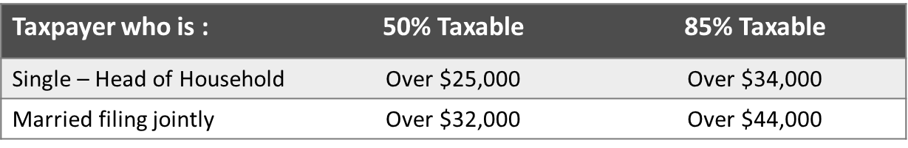
- Social Security thresholds for taxation

- Computation of taxable portion of Social Security Benefits: The taxable portion of Social Security is the minimum result of three separate calculations:
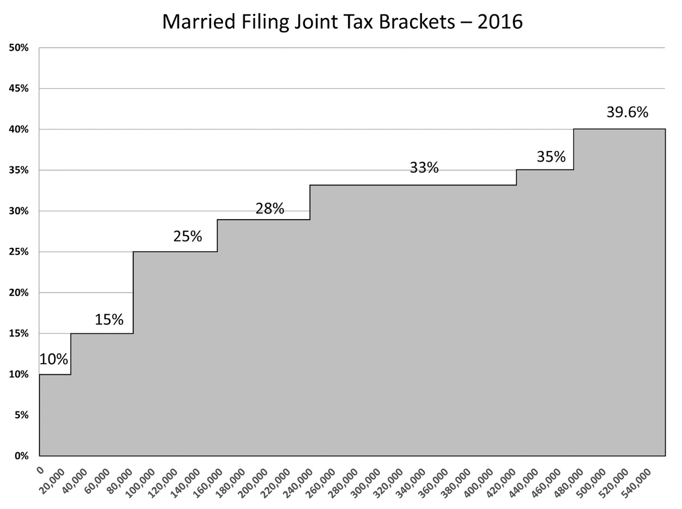

4.2 Taxation of Social Security Benefits
Taxpayer who is : | 50% Taxable | 85% Taxable
Single – Head of Household | Over $25,000 | Over $34,000
Married filing jointly | Over $32,000 | Over $44,000
Sometimes you will hear the term provisional income as it relates to figuring how much Social Security income to include on the tax return. A more precise definition however must include the term modified adjusted gross Income.
Modified adjusted gross income or MAGI starts with the AGI calculation but then it adds back the adjustments to income that were discussed in section 11.8. For most people, their MAGI and their AGI will be the same, but for people who are receiving Social Security benefits watch for self-employed individuals who have to pay self-employment taxes as well as those individuals that have IRA or SEP / SIMPLE contributions.
The reason this is important is that the provisional income calculation starts with MAGI, then adds tax free income and half of Social Security benefits. Then the process begins to determine just how much of an individual’s SS benefits will be included for taxation.
The threshold tables tend to cause people to approach the taxation of Social Security benefits as a cliff type of calculation. For example, it appears that once you cross the $44,000 threshold then 85% of all SS benefits are taxable. The fact of the matter is that Social Security benefits only begin to be taxable once they cross the thresholds that are prescribed by law. Note that there is a separate tax applied at each level which creates a blended rate of taxation. As more and more income is exposed to the 85% level of tax the 50% tax on Threshold 1 is overshadowed by the higher tax on the second tier.
Consider the following scenario. An individual has $45,000 of ordinary income plus $30,000 of Social Security benefits. Provisional income is $60,000, well above the threshold level of $44,000 which starts that 85% inclusion level for SS benefits.
Of the $30,000 of SS benefits, $19,600 would be includable for tax, leaving 35% of total Social Security benefits free of any tax. That is a significant difference from the thresholds that are indicated by the tables.
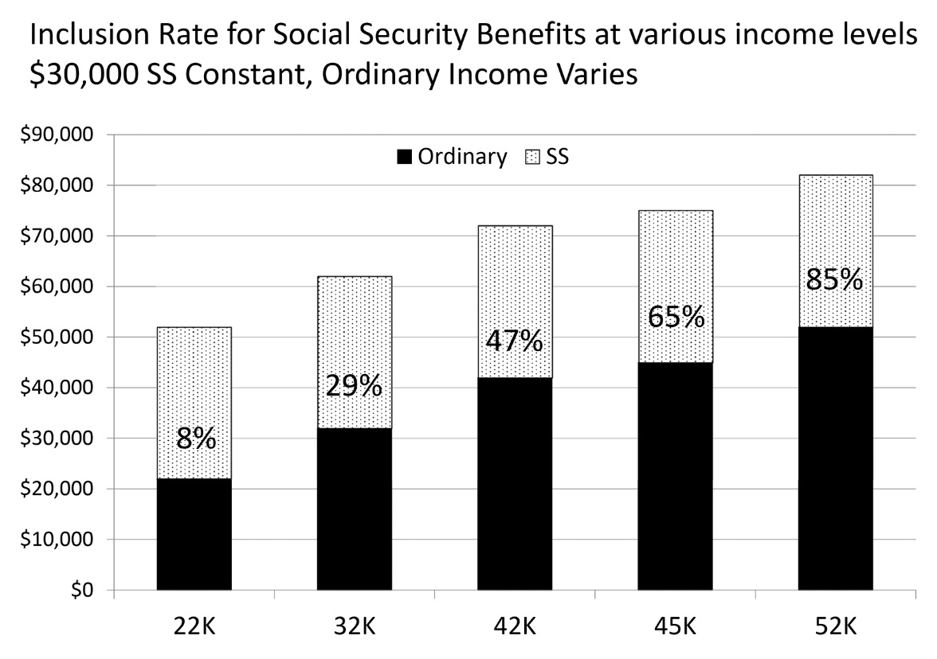
The following chart illustrates the progressive nature of Social Security taxation. Social Security income is fixed at $30,000 but ordinary income is added in various increments until 85% of Social Security income is taxable. Note that Social Security benefits to not reach a total of 85% inclusion until the total income is $82,000 (provisional income of $67,000).

4.3 Optimizing for Maximum Tax Efficiency
This next case will create the foundation for looking at several different retirement planning opportunities. First we will look at a moderate income couple and view how deferral of the claiming strategy will create the maximum blend of net income and retirement cash flow. Then using the optimal strategy as a base, we will examine the effect of additions to income, both ordinary income and long term capital gains.
Following are the basic parameters for the Rob and Jill’s case:
 | Early Claiming | Delayed  Claiming
Ordinary Income | $40,000 | $20,000
Social Security Benefits | $32,000 | $52,000
Provisional Income | $51,810 | $46,000
Household Revenue | $72,000 | $72,000
One of the primary assumptions in this type of analysis is that the client has the means to delay claiming and has some degree of control over household income. In this case, note that ordinary income has fallen in the delayed claim which could signify that the client either worked longer or drew down retirement assets such as IRA accounts so that required minimum distributions were reduced in the future. This is one of the core questions that we see in the field, how does a client supplement his or her income needs during while delaying the claiming of Social Security benefits?

A client that delays claiming benefits from the ages of 62 to 70 will experience a 76% increase in benefits by waiting. That increase does not take into consideration any cost of living adjustments to Social Security during the 8 year period in question. If one were to assume a 1.5 percent COLA during that period of time, then an additional 12 percent would be added to the benefits. This case study assumes that SS income is between the two scenarios grows from $32,000 to 52,000, representing a 73% increase.
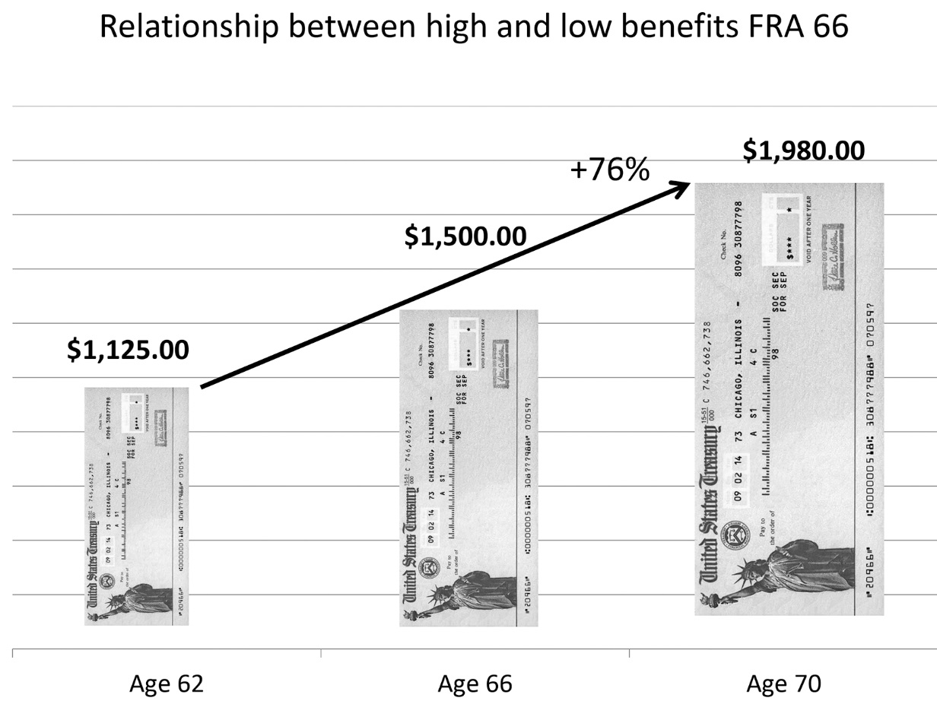
Because of the tax preferred nature of Social Security benefits, the increase is accompanied by a 55 percent decrease in the amount of Social Security that is includable for taxation.
The illustration on the following page details the steps to calculate provisional income as well as the amount that is includable for tax.
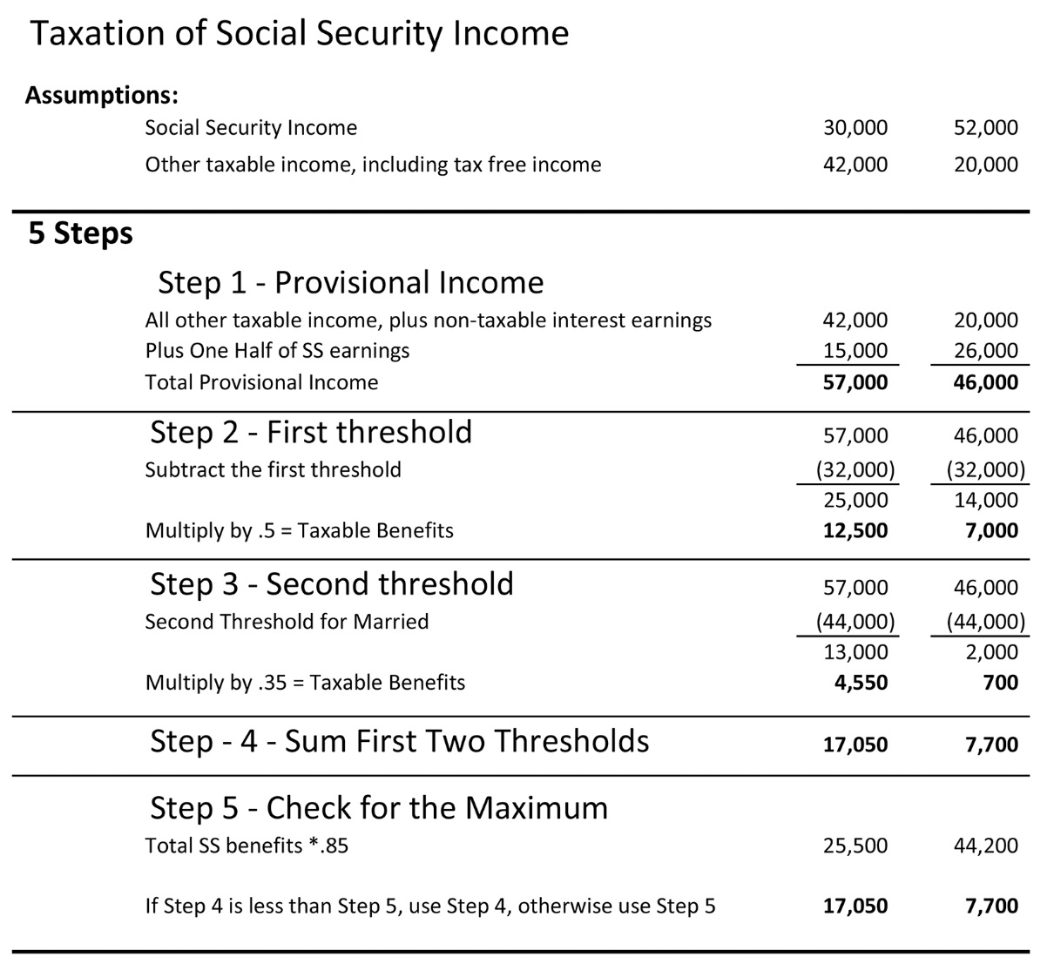
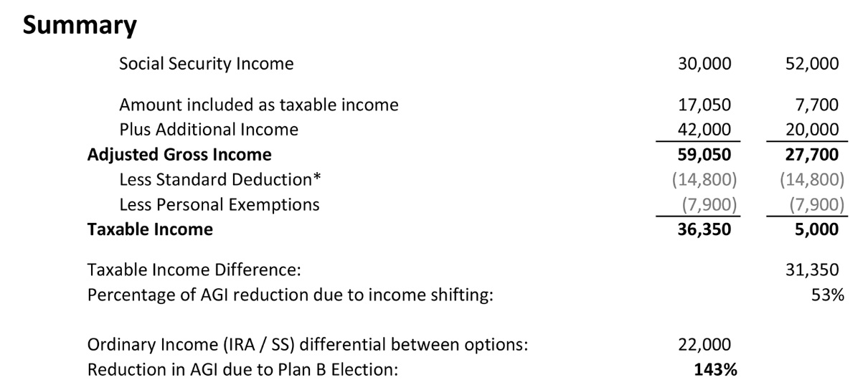
In the summary that follows note that for each $1.00 of ordinary income that was delayed and moved to Social Security we see a corresponding reduction in adjusted gross income of $1.43. This represents a significant increase in household tax efficiency.
Up to this point we have focused on the Federal income taxation of Social Security benefits. How do the states treat the taxation of Social Security benefits?
- There are 28 states and the District of Columbia that do not tax SS income.
- Nine states do not have any income tax at all.
- The balance of the states have some formula adjustment for determining how much SS income is included for purposes of state income taxation.

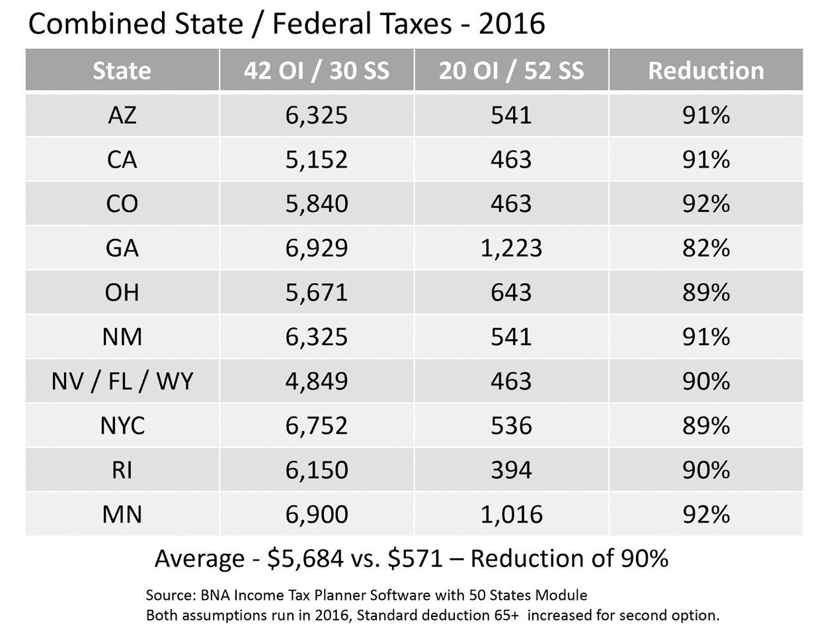

The total income tax effect for Rob and Jill is illustrated in the following table. Note that on average, combined state and Federal income taxes were reduced by 90%. This reduction adds over $5,600 in net spendable income to the family’s bottom line. For many couples this will represent a significant boost in their spendable incomes.
When the net income is viewed on the basis of income equivalency we find that delayed claiming creates a significant increase in net income, so much so in fact that the clients could retire on the equivalent of $90,000 a year of salary.
 | Delayed Claiming | Equivalent Income
Wages | 0 | 90,000
Ordinary Income | 20,000 | 0
SS Benefits | 52,000 | 0
Totals | 72,000 | 90,000
Less State & Fed Income Taxes | -672 | -11,878
Less Social Security Tax |  | -6,885
Net Income | 71,328 | 68,126
Equivalent Income | $90,000 | 71,237

4.4 Maximum Effective Marginal Rates Social Security Claimants
In our final analysis of income tax bracket, Social Security recipients and marginal rates we turn to those clients who have an additional item in their income stream, long term capital gains.
The situation that is encountered here does not require an individual or a couple to actively sell an asset such as a rental house or shares of stock. It occurs more frequently with clients that have mutual funds in their taxable investment portfolios. During the year mutual fund managers buy and sell holdings and any resulting gains or losses are distributed to the holders of the fund. When mutual funds are held inside of tax deferred accounts such as IRAs, there is no pass-through of the tax consequences to the individual investor. However, if the fund is held in an investment account that does not have tax deferred treatment, then the gains and losses are distributed to and accounted for by the investors that hold the mutual funds.
Many investors are used to receiving the tax distribution documents from their mutual funds that detail the amounts of long term and short term gains and losses as well as dividend distributions that receive preferential income tax treatment.
The map of the brackets and the effective marginal rates illustrates the following
Married, filing Joint
Both taxpayers over age 65
SS: $80,000
Pensions: $37,000
Preferred Dividends: $15,000
Tax Rates: 10, 15 and 25%
Effective Marginal Rates: 18.5, 27.75, 55.5% and 30%
  - 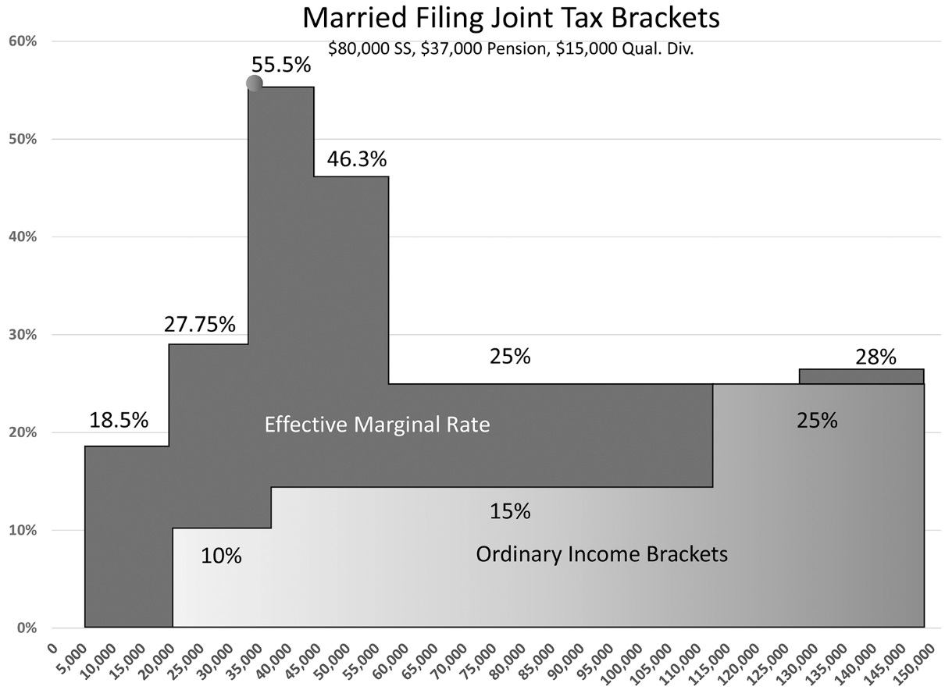
  - Conclusion

How do we put it all together?
The art of gathering all of the necessary information about client resources, needs, wants and desires and then crafting a retirement income plan that will meet those objectives is very complicated. Generally, it is accomplished by individuals who have a deep grasp of the interrelationship between areas of income tax planning, financial planning, and Social Security benefits and claiming.
Modern computer programs tend to lend the credibility of science to the process when reality dictates that the process really is more art than science. Projections run far into the future and clients are asked to make planning decision that after a short while become irrevocable. Sudden changes in mortality can make radical changes in outcomes to survivors.
The analysis of risk needs to be tightly interwoven to all aspects of crafting a combination of income sources and optimizing not only Social Security claiming but income tax planning as well. This is why the traditional “break-even” analysis of a delayed claim cannot do justice to the decision making process since it ignores tax benefits, survivor benefits and the current low interest environment that we find ourselves in.
We recommend that you find competent financial advisors who can assist you and your clients in making some of the most important financial decisions of their lives.

Stanford marshmallow experiment, Wipikedia, http://en.wikipedia.org/wiki/Stanford_marshmallow_experiment
Center on budget and policy priorities, Policy Basics: Top Ten Facts about Social Security, November 6, 2012, states that SS is the primary income source for 65% of current claimants. http://www.cbpp.org/cms/?fa=view&id=3261
Annual Statistical Supplement, 2001, 2006, 2011, 2015 http://www.ssa.gov/policy/docs/statcomps/supplement/2015/index.html
Forbes, Americans Clueless About Life Expectancy, Bungling Retirement Planning, Ashlea Ebeling, Aug 10, 2012,
Investopedia http://www.investopedia.com/terms/p/provisional-income.asp#ixzz3u2j9wxtS

