FPA of Greater Indiana

August 21, 2020

Coaching/Selling Connection
Agenda
Differentiating You in the New Sales Environment

High Trust Conversations

Communicating and Listening Effectiveness
Adapting to Styles

HIGH TRUST CONVERSATIONS
EMOTIONAL ATTRACTORS (PEA/NEA)-BOYATZIS
POSITIVE EMOTIONAL ATTRACTORS | NEGATIVE EMOTIONAL ATTRACTORS
Parasympathetic Nervous System Arousal | Sympathetic Nervous System Arousal
Possibilities, dreams, optimism, hope | Problems, expectations, pessimism, fear
Strengths | Weaknesses
Excited about trying | Should do, performance improvement plan
Novelty, experiments | Openness
Unrealistic Expectations | Actions expected, supposed to do
Resonant | Dissonant, annoying

Notes________________________________________________________________________
____________________________________________________________________________

TRUST EQUATION

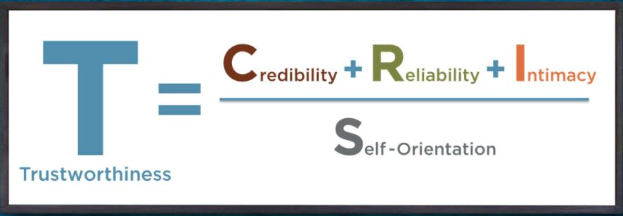

Notes__________________________________________________________________________
_______________________________________________________________________________
From www.trustedadvisor.com
HOW YOUR LISTENING AFFECTS WHAT PEOPLE SAY

Blended

Being: Being:

Creates: Creates:

Listens: Listens:

Questions: Questions:

My Agenda
Their Agenda

Being: Being

Creates: Creates:

Listens: Listens:

Questions: Questions:

From “A Field Guide for Managers: Bringing Out the Best in People” by Lyall
Detached

From “A Field Guide for Managers: Bringing Out the Best in People” by Lyall
EXPLORATORY QUESTIONS FROM BLENDED/THEIR AGENDA BOX:

- What do you look for…..?
- What have you done so far?
- What have you found…?.
- What has been your experience…?.
- How do you determine…?.
- What are your deciding factors….?
- What do you assume is stopping you from…?
- What makes you choose….?
- What is the one thing you would improve about…?
- What would you change about…?
- What are you doing to keep…?
- What happens if nothing changes?
- Help me understand your perspective.
- What other thoughts/ideas/do you have about..?
- What other perspectives can you think of?
- What would you like to see happen?
- What are other options?
- What are the advantages of doing…?
- What are the disadvantages of doing…?
- Which decision would be easier to live with?
- What have you tried?
- What has not worked so far?
- If you had a magic wand and could make this situation work for you, how would it turn out?

LEARNER/JUDGER QUESTIONS
From “Change Your Questions, Change Your Life” by Marilee Adams
JUDGER | LEARNER
- Win-lose  - Dismissive, demeaning  - Advocating  - Separate from self/others  - Fears differences  - Feedback considered rejection  - Own agenda  - Conflict: destructive  - Attacks  - Problem-focused | - Win-win  - Accepting, empathizing  - Inquiry  - Connected with self/others  - Values differences  - Feedback considered worthwhile  - Collaborative  - Conflict: constructive  - Appreciate; resolve; create  - Solution Focused

Notes___________________________________________________________________
________________________________________________________________________

JUDGER/LEARNER MINDSETS
JUDGER | LEARNER
Problem-focused; Know-it-all; Reactive; Automatic; Competitive; Assumptive  - How can I stay in control?  - How can I make them see it my way?  - What can prove that I am right?  - What will make me “look good”  - How can I win? | Open-minded; Responsive; Proactive; Many choices; Cooperative; Accepting  - What are my assumptions?  - What do I need to know?  - What is missing that might be important?  - What else could I think about this?  - How can we both win?

Notes___________________________________________________________________
________________________________________________________________________

Using DISC Style in Sales/Customer Service

Process | Dominance | Influence | Steadiness | Conscientiousness
Connecting | Clarify purpose before questioning  Limit socializing  Be prepared | Personal before business-talk about self and interests  Stories  Pace | Warm and informal. Show tact and sincerity  Show interest in them personally | Focus on process and direction. Allow client to show expertise  Bring an agenda
Questioning | Result-oriented  Listen to suggestions  Give direction for questions | Enthusiasm  Listen to their dreams and goals  Gently guide back | Patience  Listen for impact on them and relationships  Avoid interruption | Facts and data  Listen for concerns, reasoning, and suggestions  Stay on topic
Presenting | Efficiency, savings, bottom-line  Brevity | Positivity-impact on what is important to them  Ask for ideas | Predictability and harmony  Simplification  Non-threatening | Accuracy, logic, solution quality  Avoid pressure  Emotionally detached
Responding | May be blunt in response-focus on results | May show doubts-use testimonials | Probe for real concerns-may be change avoidant | Clear concise information. Reinforce logic
Commitment | Provide options-place decision making with person  Direct with interest | Upbeat-use examples for moving forward  Slow down if moving too fact | Provide step-by-step actions. Gain commitment by not pushing | Clarify priorities. Allow time and space for processing.  Suggest pilot or small endeavor
Follow-up | Follow-up immediately-address any concerns that arise  Ask about satisfaction | Provide on-going reminders of right decision. Ask about use of website, etc.  Avoid any frustrations with use by information | Remain in touch. Evaluate process. Predictability and consistency with follow-up  Private phone number | Timetable for follow-ups. Measures of success.  Email ideas  Focus on and reinforce quality and value
Emails and Voicemails | Clear articulation. Purpose of call or email. What you want them to do and expectations for next step. | Warm, expressive, and upbeat. Suggest meeting to reinforce/share ideas. | Slow down speech. Sound personable yet professional. Thank in advance for returning email or call. | Slow down speech. Clear articulation with reason for call and what you want. Set expectations about next step.

STYLE WATCHING AND DESCRIPTORS
 | High D Style | High I Style | High S Style | High C Style
Pace | Fast/Decisive | Fast/Spontaneous | Slower/Relaxed | Slower/Systematic
Priority | Goal | People | Relationship | Task
Seeks | Productivity, Control | Participation, Applause | Acceptance | Accuracy, Precision
Strengths | Administration, Leadership  Pioneering | Persuading, Motivating  Entertaining | Listening, Teamwork  Follow-through | Planning, Systemizing  Orchestrating
Opportunities | Impatient  Insensitive to others  Poor Listener | Inattentive to detail  Short attention span  Low follow-through | Oversensitive  Slows to begin action  Lacks global perspective | Perfectionist, Critical  Unresponsive
Fears | Being taken advantage of | Loss of social recognition | Sudden Changes, Instability | Personal criticism of their work
Irritations | Inefficiency, Indecision | Routines, Complexity | Insensitivity, Impatience | Disorganization, impropriety
Under Stress may become | Dictatorial, Critical | Sarcastic, Superficial | Submissive, Indecisive | Withdrawn, Headstrong
Gains Security Through | Control, Leadership | Playfulness, Other’s approval | Friendship, Cooperation | Preparation, Thoroughness
Measures Personal Worth by | Impact or results  Track records and products | Acknowledgements  Applause, Compliments | Compatibility with others  Depth of contribution | Precision, Accuracy  Quality of results
Workplace | Efficient, Busy, Structured | Interacting, Busy, Personal | Friendly, Functional, Personal | Formal, Functional  Structured

