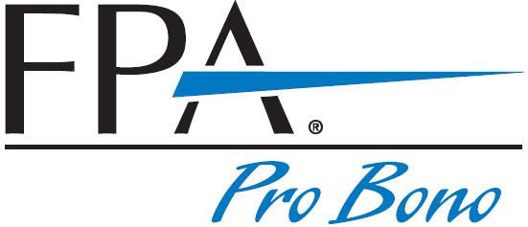
Financial Planning Association
of Hampton Roads
Pro Bono Program
Sign-up Sheet
<<Title of Educational Seminar>>
<<Date>>

This free educational seminar is co-sponsored by <<NAME OF PARTNER ORGANIZATION>> and FPA of Hampton Roads. There is no fee or charge for this seminar. All information provided at this seminar will be general in nature and may not be applicable to individual cases. No financial planning client engagement is implied or established. By signing below, you are recording your attendance and releasing FPA volunteer(s), FPA, and <<NAME OF PARTNER ORGANIZATION>> from any and all liability related to this seminar.

Name | Phone/Email (optional)
1.
2.
3.
4.
5.
6.
7.
8.
9.
10.
11.
12.
13.
14.
15.

Sheet Number _____ | The Financial Planning Association’s pro bono programs are funded in part by generous grants from the Foundation for Financial Planning | 