# FPA of Idaho

February 2016

Inside this issue:

February Newsletter

## February 2016 Newsletter[https://encrypted-tbn3.gstatic.com/images?q=tbn:ANd9GcSnYtcFljFabEugkYj4P5WF-lEi25hB6UjEgFdR1RqfM6XXJpWnww](http://www.google.com/imgres?imgurl=http://www.businesscreditcards.com/bootstrapper/wp-content/uploads/Piggy-bank-slops.jpg&imgrefurl=https://www.businesscreditcards.com/bootstrapper/piggy-bank-getting-the-slops/&h=283&w=425&tbnid=G3u_nvqj2XOGNM:&zoom=1&docid=eQ8FTUrDdRhCmM&hl=en&ei=kYg5U-_yEuHXygGKwYHwBg&tbm=isch&ved=0CK4BEIQcMDc4ZA&iact=rc&dur=1618&page=7&start=138&ndsp=24)

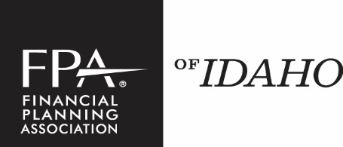

President’s Message 1

Board of Directors 2

New Members 2

Long-Term Members 2

Chapter Meetings 2

Sponsors 3

***Important Dates:***

Local Chapter Meetings: February 16, 2016, March 15, 2016, and April 19, 2016

***A Message from the President:***

Welcome to our 2016 FPA of Idaho meetings!

Our first lunch meeting is February 16th from noon to 1:30pm at the Arid Club. The speaker will be Patty Highley from the Department of Finance with some words of wisdom from our local regulator. The sponsor will be Ascendant Capital. Please personally thank them both for their participation at our meeting. Please RSVP to Lisa Fyan at [fpaidaho@msn.com](mailto:fpaidaho@msn.com) if you are interested in attending and invite a colleague!!

As with any volunteer organization, there are always a select few that make it what it is. It is kind of like an 80/20 rule for most companies. That being said, we have a few individuals who have been steadfast in their contributions to our organization over the years and continue to do so without a whimper. However, I am sure they would be more than willing to relieve some of their responsibilities if given the chance. Therefore, if you have any inclination to want to participate more in our organization and become a board member, please come talk to me or any of our board members.

As always, if you have suggestions for sponsors or speakers or want to discuss ways we can increase the value of your membership, please let me know.

Thanks.

Brett Gallagher

President, FPA of Idaho

FPA of Idaho | http://chapters.onefpa.org/Idaho | phone 208.672.1379

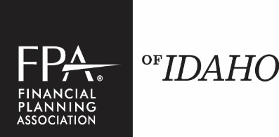

Ben Boettcher – 10 years

Crystal Edson – 9 years

Robert Frey – 17 years

Jean Hanson – 15 years

Suzanne Hazlett – 14 years

Stephen Stech – 11 years

Thomas Steelman – 10 years

“As with any volunteer organization, there are always a select few that make it what it is.”

### Congratulations to Our Long-Term Members!

Save the dates for our Spring Schedule

● February 16 ● March 15 ● April 19

Arid Club ● 1137 W River St, Boise

Guests are welcome, $25 for lunch

1 CE and CFP credit is available to members

Business Professional Attire Please

Lisa Cooper

Kathy Stearns

**2016 Board of Directors**

**President**

Brett Gallagher

Principal Financial Group

342-2765 x115

**Treasurer**

David Allen, CPA

David L. Allen CPA, PLLC

991-8424

**Program Director Chair**

Larry Halvorson ChFC, CLU

Key Private Bank

890-0310

**Public Relations Chair**

Carey McNeal

Buffington Mohr McNeal

338-5551

**Sponsor Chair**

Mark Rupp, CFP®

Capital Financial Solutions

629-4660

**Membership Chair**

Cheri Pinkerton, CFP®

The H Group

853-7770

**Membership Co-Chair**

J. Chris Hendrickson, CFP®

Berkeley Inc.

853-6980

### Chapter Meetings

### Welcome To Our New Members!

Page 2

February 2016

“Our chapter website is http://Chapters.onefpa.org/Idaho”

Next chapter meeting for spring is February 16, 2016



Homestreet Bank—Kevin Helmick and Jim Crotty

Pacific Life-Greg Streuber

Ascendant Capital – Nick Headley

Do not forget to visit our website to

RSVP for all meetings and special

Events with the FPA!

[**http://chapters.onefpa.org/Idaho**](http://chapters.onefpa.org/Idaho)

**Bookmark our homepage and visit often!**

### Spring Chapter Meetings 2016

### RSVP

Page 3

February 2016

### Sponsors