NEWS


Idaho News
April 2009


ase RSVP to Lacy at 468-0231 by Friday, November 12
“Good Intentions:
Disastrous Outcomes ”

Presented by, Michael J. Ling, CFP®,
Berkeley, Inc.

Tuesday, April 21, 2009

The Arid Club
1137 W River St, Boise, Idaho

12:00 – 1:30 PM

Local Members – Free

Non-Members - $25

First time visitors may join us for a complimentary lunch

One CFP® and Idaho Insurance CE Credit Provided!

RSVP at 468-0231

To view the entire newsletter, please
Visit our website at: http://www.fpanet.org/Chapters/Idaho

Idaho Chapter
2009 Board of Directors

President
Raoul Allen, CFP®, EA
Rohrer & Associates
368-9853

Past President
David Turner, CFP®
US Bank Private Client Group
383-7211

President-Elect
Dennis Rompala
LTC Solutions
344-9184

Programs / Sponsors
Larry Halvorson, CLU, ChFC
Nexus Wealth Mgmt.
424-8080

Pro-Bono
Tom Steelman
The Helmstar Group
284-7623

Membership Director
Jack Thomas
AFA Financial Group, LLC
319-3618

Chapter Administrator
Lacy Hazel
FPAIdaho@msn.com
468-0231

Upcoming Events:

April 9: New Member and Member Appreciation Breakfast. 8:00am. Elmer’s Restaurant on Capitol.

The Membership Committee
Invites You to...
Spring 2009

Member Appreciation
Breakfast

WHO:
Current members and their guests, new members, board members, prospective members

WHAT:
Breakfast, networking, provide input on upcoming events and topics

WHERE:
Boise Elmer’s on Capitol

WHEN:
Thursday, April 9, 2009
8:00 to 9:30 am

WHY:
An opportunity to meet the board,
Learn about FPA Idaho, door prizes


Message From the President

Extraordinary times may be the best proving ground for the value brought to clients by FPA members and the services they provide. Over the past year, we have witnessed an economic collapse that has affected virtually everyone. Our investments, jobs and homes have all taken hard hits and it appears for awhile longer. Even though we are going through tough times, FPA members are committed to helping families meet their own unique goals and objectives by adhering to a systematic financial process. The FPA and its members are also dedicated to maintaining strict standards and ethical business practices to ensure everyone they serve receives the peace of mind they are entitled to. I wish to remind our members that we are sponsoring a membership recognition breakfast on April 9th to recognize new members that have recently joined the FPA. This represents an excellent opportunity to meet fellow members and share experiences when we might not otherwise.

Raoul Allen, CFP®
2008-2010 President, FPA Idaho

This Month’s Speaker – Michael J. Ling, CFP®

Mike earned a BA degree in economics from the University of California at Berkeley in 1993. His coursework focused on two areas: quantitative analysis of macroeconomic changes, and analysis of historical social and economic trends. He’s the founding partner at Berkeley, Inc.: a firm that works with mid to high net worth clients both managing their investments and providing financial planning. Berkeley Inc has 185 clients and manages $100 million.

Michael is the past president of the Treasure Valley Economics Association and Capital Matrix, a not-for profit that provides SBA loans to businesses. He was also the founding president of Life’s Kitchen.

National News

The 2009 Heart of Financial Planning Distinguished Service Awards
The Financial Planning Association® (FPA®) is seeking nominations for the 2009 Heart of Financial Planning Distinguished Service Awards that will be presented at FPA Anaheim 2009, October 10-13.

Consider nominating an FPA individual member, a financial planning firm, an FPA chapter, a professional (e.g. attorney, CPA, professor, journalist) or any other organization or individual that you believe has done extraordinary work to contribute or give back to our financial planning community and/or the public. Please do not nominate FPA staff for this award

FPA is at the heart of financial planning connecting those who deliver, support and need financial planning. Nominees should embody the heart of financial planning and should also represent FPA’s core values of competence, integrity, relationships and stewardship.

The deadline for nominations is June 9, 2009. Nominations should be in the form of a one- to three-page letter and include the following information:
- Your affiliation with the nominee (FPA member, chapter leader, employee, associated professional, etc.).
- Clarify the nominee’s excellence in demonstrating FPA’s Core Values and the nominee’s extraordinary service and stewardship to contribute or give back to the financial planning community and/or the public.
- Explain why your nominee should be considered for this award. Focus on key points and provide specific examples to support your recommendation. If you are recommending a company or organization, focus on the contributions of the company or organization.
- Be succinct, make every word count.
- Make the ending strong, providing a summary of why you are recommending the nominee.

Send nominations to:
Heart of Financial Planning Distinguished Service Awards
Financial Planning Association
4100 E. Mississippi Ave. Ste. 400
Denver, CO 80246

FPA Board of Directors
Are you passionate about the future of financial planning? Would you like to help chart the course for FPA? Then why not submit a nomination for service on FPA’s Board of Directors?
The Board of Directors sets a vision for the Association, positions FPA as The Heart of Financial Planning™, and contributes to building the profession.

Board members must think strategically, engage in flexible, ongoing open dialogue, work collaboratively, and advance FPA’s Primary Aim by exercising vision and stewardship for the benefit of FPA and its stakeholders.

As a leadership and advocacy organization, FPA is committed to identifying and engaging exceptional individuals who are ready and willing to serve FPA and the financial planning profession. Volunteering for the Board of Directors is just one of many ways you can serve as an FPA volunteer leader.

Our nationwide network of chapters is volunteer-member driven. There are also numerous opportunities to engage in pro bono activities, such as leading underserved individuals and families, disaster victims and our armed forces toward financial strength and the fulfillment of their financial dreams.

If you wish to be considered for service on our Board of Directors, contact Wendy Todd for more information and a nomination package. Nominations for FPA’s 2010 Board of Directors are due July 14, 2009.

Learn more about other FPA leadership opportunities on the FPA Web site.

Nominations Deadline for P. Kemp Fain, Jr., Award Announced
FPA is seeking nominations for the P. Kemp Fain, Jr., Award to be submitted by June 16. The award recognizes an individual who has made outstanding contributions to the financial planning profession and will be presented at FPA Anaheim October 10-13.

P. Kemp Fain, Jr., formed the first International Association for Financial Planning (IAFP) chapter in 1971 and served as its first president. Additionally, Fain served as president and chair of the Institute of Certified Financial Planners (ICFP) from 1983 until 1985. He was the first person to officially enroll in the CFP® certification program and was a member of the inaugural class of CFP conferees in 1973.

In keeping with Fain’s example, nominees for the award should be professionals who have made significant contributions to the financial planning profession in the areas of service to society, academia, government and professional activities. They must also exemplify FPA’s Core Values of integrity, competence, dedication to relationship building and stewardship. Please submit nominations by June 16, in a letter, up to three pages, describing why you believe the individual should be considered to:

P. Kemp Fain, Jr. Award
Financial Planning Association
Suite 400
4100 E. Mississippi Ave.
Denver, CO 80246
Sponsors

John Bellamy, AAPA
Vice President of Mr
tng &
Annuity Marketing Director
jbellamy@unitedheritage.com
707 E. United Heritage Ct.
Meridian, ID 83642-3527
(208) 493-6100


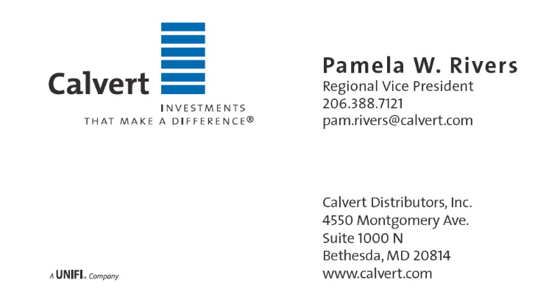

Terrie L. Trevino
Blue Cross of Idaho
Dental & Ancillary Product Manager
Phone: (208) 363-8757
Cell: (208) 695-8932
Fax: (208) 331-7582

Financial Planning Association of Idaho
5702 E Victory Rd
Nampa, ID 83687

