NEWS


Idaho News
December 2008
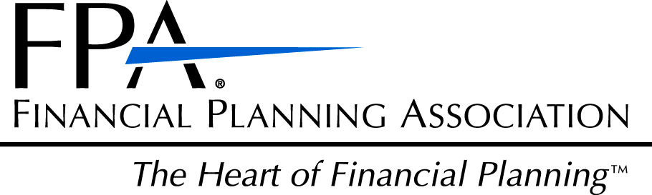

The Financial Planning Association of Idaho
presents

The “LTC Consiousness Tour”

Guest Speaker: Stephen Moses

Center for Long-Term Care Reform (Seattle, WA)*
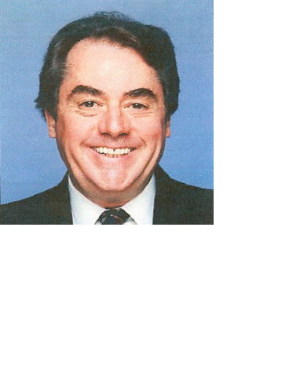

Sponsored by

Long Term Care Solutions

Thursday, December 4, 2008

Registration 8:30am or 1:30pm
- Can the current non-system survive and how will it change?
- Will services be available when seniors need them in the future?
- Who will pay?
- What will happen to the government's LTC financing programs?
- How can advisors help more seniors protect themselves from the LTC risk?
- How can we build a "phalanx of professionals" around seniors to help them protect themselves from the legal and financial risks of aging?

US Bank Building
101 S. Capitol Blvd., 2nd Fl
Boise, Idaho

Register for either session: 8:30-11:00a.m. OR 1:30-4:00p.m.
Phone: (208) 383-7211, or E-mail: sharman.horvath@usbank.com
(Idaho Insurance and CFP® CE Credits Provided)
* Stephen Moses is president of the Center for Long-Term Care Reform* in Seattle, WA. Mr. Moses is nationally recognized as an expert and innovator in the field of long-term care. The Center for Long-Term Care Reform is a private, nonpartisan think tank and public policy organization dedicated to ensuring quality long-term care for all Americans.

Local News
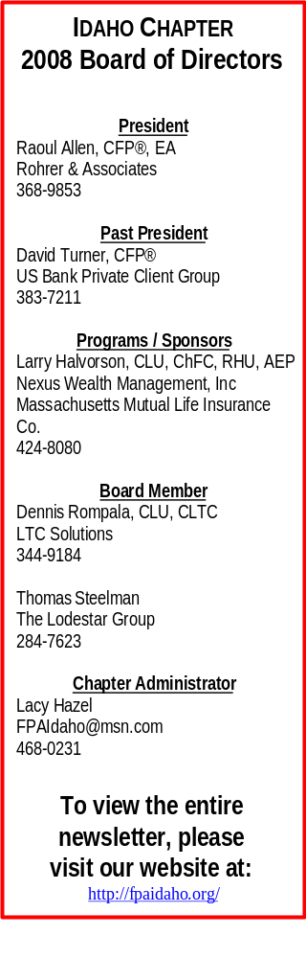
Thank you to Chris Hendrickson, CFP® who volunteered to speak to MWI
Veterinary Supply, on behalf of the FPA Idaho was well. Chris spoke to about
23 employees on “Finance 101”including budgeting, saving, and what he does
as a financial planner. Thank you Chris!

Your support is very much appreciated!

Tom Steelman will begin volunteering his time with Junior Achievement Of
Idaho in January. Tom will volunteer for one hour, one day a week for five
weeks teaching kids in grades 3-6 about the basics and benefits of finances.

This is a great opportunity for FPA Idaho to get out into the community

and educate our youth on how to be financially responsible.

If you are interested in volunteering with Junior Achievement of Idaho through
our local association, please contact Lacy Hazel at 468-0231.

Just a reminder, there will be no member luncheon in December.
Happy Holidays!

Upcoming Events:
February 17: Member Luncheon. Arid Club. Noon-1:30pm. Topic TBA. Idaho insurance and CFP® CE credits provided. Call Lacy Hazel at 468-0231 to reserve your seat.

March 17. Member Luncheon. Arid Club. Noon-1:30pm. State Treasurer Ron Crane. Idaho insurance and CFP® CE credits provided. Call Lacy Hazel at 468-0231 to reserve your seat!

Welcome!
Doug Carter Susan Rueger
American Independence Securities Group Mountain Home, Idaho
Eagle, Idaho

Thank you to our 2008 Sponsors

John Bellamy, AAPA
Vice President of Mrktng &
Annuity Marketing Director
jbellamy@unitedheritage.com
707 E. United Heritage Ct.
Meridian, ID 83642-3527
(208) 493-6100


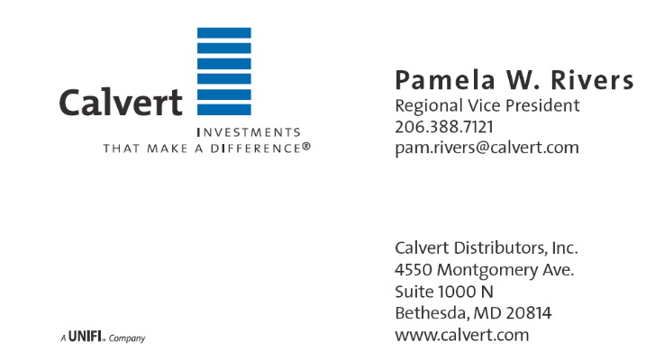

Terrie L. Trevino
Blue Cross of Idaho
Dental & Ancillary Product Manager
Phone: (208) 363-8757
Cell: (208) 695-8932
Fax: (208) 331-7582

