NEWS


Idaho News
June 2009


ase RSVP to Lacy at 468-0231 by Friday, November 12

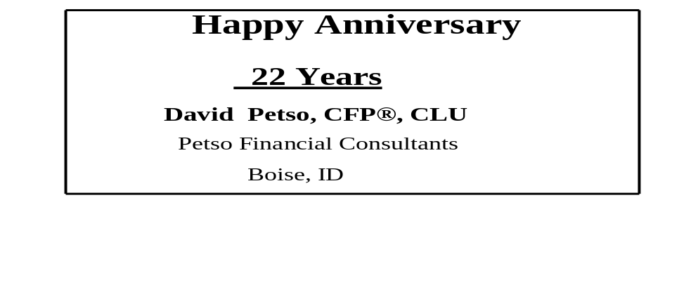

2009 Calendar
Please view the calendar available on the website http://www.fpanet.org/Chapters/Idaho for upcoming events, meetings and information

Need a Planner
Jack Thomas of AFA Financial Group, LLC is looking for planners that do solely financial plans for a fee.

If you are an FPA member or other planner who does only financial plans, please contact Jack at:

Wealth Advisor
AFA Financial Group, LLC
208.319.3618 direct
208.720.6918 mobile
jthomas@afamail.com
950 W. Bannock, 11th Floor Boise, ID 83702

Idaho Chapter
2009 Board of Directors

President
Raoul Allen, CFP®, EA
Rohrer & Associates
368-9853

Past President
David Turner, CFP®
US Bank Private Client Group
383-7211

President-Elect
Dennis Rompala
LTC Solutions
344-9184

Programs / Sponsors
Larry Halvorson, CLU, ChFC
Nexus Wealth Mgmt.
424-8080

Pro-Bono
Tom Steelman
The Helmstar Group
284-7623

Membership Director
Jack Thomas
AFA Financial Group, LLC
319-3618

Chapter Administrator
Lacy Hazel
FPAIdaho@msn.com
468-0231

Message From the President
Several FPA board members recently attended Junior Achievement’s annual fund raiser and awards ceremony to recognize sponsors and teachers for their exceptional service to JA, and to also recognize several students for their outstanding academic achievement and personal involvement in JA this past year. Katie Vanderzwan, President of the Junior Achievement of Idaho, hosted the event. At the national level, the FPA has been very supportive of Junior Achievement and she addressed the need for volunteers to help carry out this important program.

JA’s purpose has been to educate and inspire young people to understand and value free enterprise, business and economics. Basically, JA brings the real world to students and currently offers programs to students grades K-12. Volunteers are the heart and soul of JA. JA provides the materials, support and training but it is the volunteers who bring the programs to life. I would like to commend FPA members Tom Steelman and Doug Carter for their participation and if anyone is interested in helping or would like additional information, I urge you to contact them or you may contact either the Idaho FPA or the Junior Achievement of Idaho. JA represents a great way for our chapter to participate in an important community service activity.

Raoul Allen, CFP®
2008-2010 President, FPA Idaho

National News
Please be advised that the SEC has posted a custody notification letter on its website that can be used by investment advisers and financial planners to notify clients that SEC examiners may contact them to verify account holdings in wake of the Madoff scandal. Only those client accounts for which the adviser holds custody are likely to be contacted by the SEC. The SEC confirmation form given to the client requests the account balance from the adviser's records as of a given date, including the client's last deposit and last withdrawal.

The SEC's model letter makes clear that the client's cooperation is voluntary, and emphasizes that the request should in no way be construed that there is a problem involving the adviser.

We are told that the SEC is likely to contact the adviser first in order to request client names and addresses prior to the inspection, and at such time the adviser may want to notify clients of the possible SEC examination. The link to the SEC letter and confirmation request are in the link below. You may want to notify chapter members of this new SEC link, which as posted recently on the SEC's web site.

http://www.sec.gov/about/offices/ocie/routine_account_information_confirmation.pdf

Please be aware that in addition to the recent SEC requests for specific client information, the Commission has also proposed changes to the custody rule that would require an independent surprise audit of investment advisers registered with the SEC who hold custody or have asset management fees automatically deducted by a third-party custodian. FPA plans to comment on this proposed change to custody rules in cooperation with its national Government Relations Committee.

If you have any questions, please contact Duane Thompson at 202.449.6341.

Sponsors

John Bellamy, AAPA
Vice President of Mr
tng &
Annuity Marketing Director
jbellamy@unitedheritage.com
707 E. United Heritage Ct.
Meridian, ID 83642-3527
(208) 493-6100


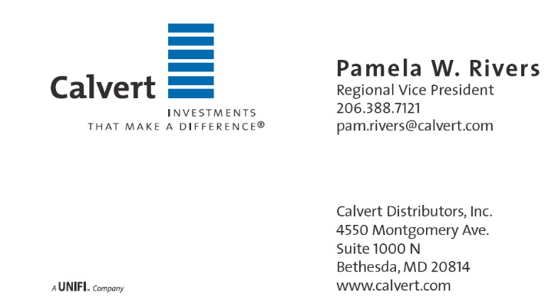

Terrie L. Trevino
Blue Cross of Idaho
Dental & Ancillary Product Manager
Phone: (208) 363-8757
Cell: (208) 695-8932
Fax: (208) 331-7582

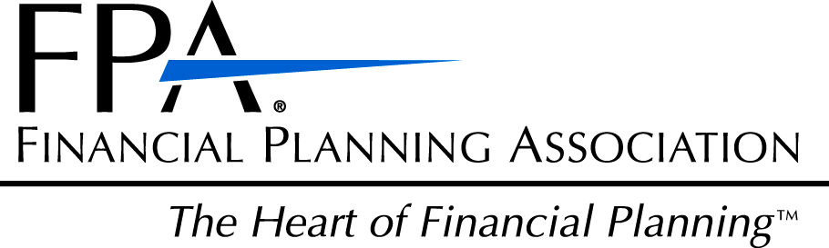

Financial Planning Association of Idaho
5702 E Victory Rd
Nampa, ID 83687

