NEWS


Idaho News
May 2009
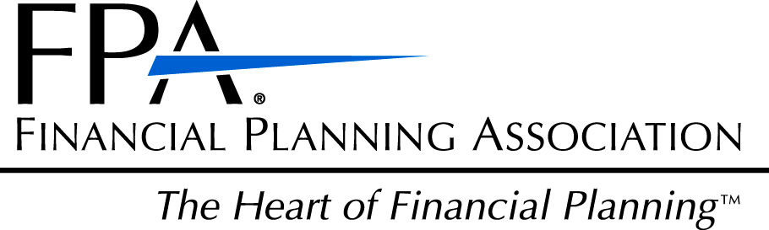

ase RSVP to Lacy at 468-0231 by Friday, November 12
2009 Calendar

BOARD MEETINGS:
May 19 – 11:30am–12:30pm, fall schedule
July 21 – 11:00am – 1:00pm, Strategic Planning Meeting
August 18–11:30am–12:30pm,to complete unfinished business
September 15 – 10:45am–11:45am Arid Club
October 20 – 10:45am–11:45am Arid Club
November 17 – 10:45am–11:45am Arid Club

If you have items you would like to add to the Board’s agenda, please contact Lacy one week prior to the Board Meeting. 208-468-0231

LUNCHEONS:
(Arid Club: 12:00 – 1:30pm) Topics TBA

September 15
October 20
November 17

One CFP® Continuing Education credit will be provided
One Idaho Insurance Continuing Education credit will be provided

SOCIAL EVENTS:
(Keep watch for more information)
Social Event – Send us your ideas!

Great Networking Opportunities!

COMMUNITY EVENTS:
Junior Achievement Dinner/Auction May 14
Financial Planning Week, October 5-11
Smart Women, Smart Money Conference:
Boise, October 3
Coeur d’Alene, October 24

Idaho Chapter
2009 Board of Directors

President
Raoul Allen, CFP®, EA
Rohrer & Associates
368-9853

Past President
David Turner, CFP®
US Bank Private Client Group
383-7211

President-Elect
Dennis Rompala
LTC Solutions
344-9184

Programs / Sponsors
Larry Halvorson, CLU, ChFC
Nexus Wealth Mgmt.
424-8080

Pro-Bono
Tom Steelman
The Helmstar Group
284-7623

Membership Director
Jack Thomas
AFA Financial Group, LLC
319-3618

Chapter Administrator
Lacy Hazel
FPAIdaho@msn.com
468-0231

Message From the President
On behalf of the Idaho FPA, I would like to thank those members who attended our recent Membership Recognition Breakfast. Several guests were present and all had an opportunity to intermingle with the members who, in round-table fashion, shared with the group their reasons for joining the FPA. In spite of the economic turmoil we are currently experiencing, there is much interest in financial planning. This represents a perfect time to reach out to those who are new to the profession or who are interested in becoming financial planners and think about becoming members of the FPA.

Our regularly scheduled luncheon meetings will not resume again until September, so I wish to take the opportunity to thank the board members for their hard work and to thank current members for their continued support and dedication to the FPA. If you have any questions about the FPA or wish to share ideas with any of the board members, please do not hesitate to get in touch with us. This is your chapter, so please let us know how we can assist you.

Raoul Allen, CFP®
2008-2010 President, FPA Idaho
New Members Anniversaries
Rick Boss 26 Years
Table Rock Financial Planning Jerry Croce, CFP®
Boise, Idaho H D Vest Financial Servecs
Bellevue, Idaho

Stan Mock, CFP® 13 Years
Financial Planning Services, LLC Joel Server, VMD, MBA
Boise, Idaho KMS Financial Services
Boise, Idaho

Junior Achievement’s
Blackboards to Business “Reach for the Stars” Dinner & Auction 2009
This year, FPA Idaho is pleased to announce its sponsorship with the Junior Achievement of Idaho and their “Reach for the Starts” Dinner/Auction. JA’s special events bring in more than half of their operating budget. This annual dinner with auction has been a staple in their fundraising program for over fourteen years. This year’s goal of $15,000 will support their local education programs, designed to teach and inspire young people to value free enterprise, business and economics.

Those attending this year’s dinner/auction will be 2009 JA volunteer and new member, Doug Carter, board members, Jack Thomas, Raoul Allen, Lacy Hazel, and Initiative Learning Center educators, Nancy McDonald, Chelsea Denney, and Linda Wheaton.

If you are interested in volunteering with Junior Achievement or if you would like more information, please contact Tom Steelman at tom@helmstargroup.com

National News
The Financial Planning Coalition (Certified Financial Planner Board of Standards, Inc., Financial Planning Association® and National Association of Personal Financial Advisors) is pleased to provide an update on the most recent activities of the Coalition.

Consistent with the Statement of Understanding (released by the Coalition on January 7, 2009), Coalition members have been working on a legislative agenda that would recognize financial planning as a regulated profession, subject to competency and ethical standards, so the American consumer can easily identify trusted and competent financial advisors. The Coalition has also continued to reach out to government, consumer, and financial services organizations to raise awareness about the need for standards and to seek support of the Coalition's goals.

For more information, or to read the entire article, please contact Lacy Hazel at 468-0231.

FPA is pleased to announce the launch of the new Member Advantage Program that connects FPA members with quality product and service providers. Start taking advantage of members-only discounts on:

Long Term Disability Insurance
Enjoy savings up to 50% on Long Term Disability Insurance provided through Ryan Insurance Strategy Consultants. The open enrollment period is available to all members through May 31, 2009.

Errors and Omissions Insurance
Save five percent and receive quality coverage and excellent customer service through the Cambridge Alliance. Coverage has been offered through this provider since 1988.

Auto Insurance
Save up to eight percent off GEICO's already low rates with this new member benefit. Take advantage of your free rate quote today.

Wireless Phone Center
Shop wireless phones, carriers and accessories and enjoy special members-only savings. A vast selection of carriers and products available.

Travel Vacation Center
Enjoy discounts on vacation packages for yourself, your family or your business. Individual and group packages available.

Online Mall
Take advantage of savings and cash back earnings on what most people already do regularly – shop online. Over 500 best-in-class retailers to choose from.

Identity Theft Protection
Every three seconds another identity is stolen. Protect your identity with discounts on LifeLock, the leader in identity theft protection.

IPS AdvisorPro®
Build quick and easy Investment Policy Statements through this Web-based software created by advisers for advisers. Member discounts are available on your first year subscription.

Enjoy the group buying power of FPA with the new Member Advantage Program. Visit www.FPAnet.org and
click on "Discount and Insurance Programs" under the Membership tab for more information. Also, check out
existing programs such as the Financial Planning Association Platinum Plus® MasterCard® Credit Card or
special FedEx discounts.

Sponsors

John Bellamy, AAPA
Vice President of Mr
tng &
Annuity Marketing Director
jbellamy@unitedheritage.com
707 E. United Heritage Ct.
Meridian, ID 83642-3527
(208) 493-6100


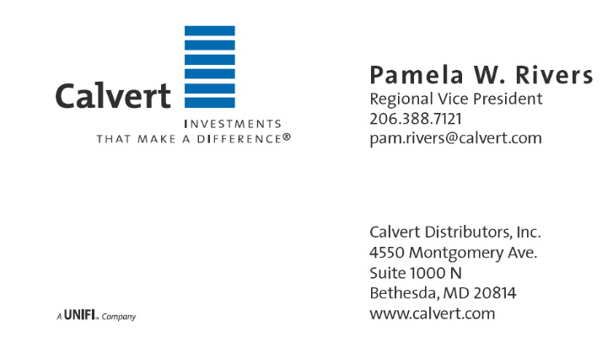

Terrie L. Trevino
Blue Cross of Idaho
Dental & Ancillary Product Manager
Phone: (208) 363-8757
Cell: (208) 695-8932
Fax: (208) 331-7582

Financial Planning Association of Idaho
5702 E Victory Rd
Nampa, ID 83687

