NEWS


Idaho News
November 2008
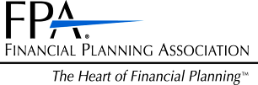

ase RSVP to Lacy at 468-0231 by Friday, November 12
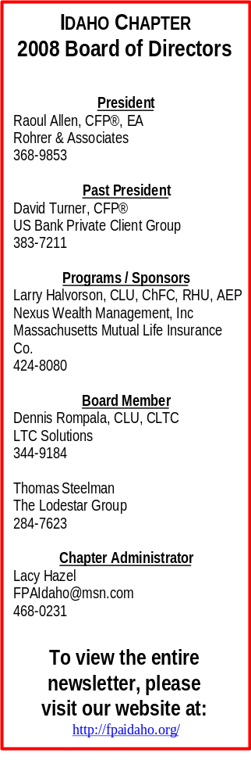
Panel Discussion on Economy and Changes in Regulation

Featuring Bob Wreggelsworth, Trust Officer, CFP®, CPA, Attorney at Law,
John Chouinard, CLU, ChFC,
And Idaho Department of Insurance

Tuesday, November 18, 2008

The Arid Club
1137 W River St, Boise, Idaho

12:00 – 1:30 PM

Local Members – Free

Non-Members - $25

First time visitors may join us for a complimentary lunch

Please RSVP to Lacy by Friday the 14th at 468-0231 or fpaidaho@msn.com

One CFP® and Idaho Insurance CE Credit Provided!

Thank you to our November Sponsor!


Upcoming Events:

December 4: LTC Seminar featuring Steve Moses. US Bank Bldg. 9-11am OR 1-3pm. Idaho insurance and CFP® CE credits provided. Call Dave Turner at 383-7211 to sign up.

February 17: Member Luncheon. Arid Club. Noon-1:30pm. Topic TBA. Idaho insurance and CFP® CE credits provided. Call Lacy Hazel at 468-0231 to reserve your seat.

NOVEMBER IS
Long-Term Care Awareness Month

The Ideal Time to Focus on LTC Planning!

Local News
Local Dues notices for 2009 will be e-mailed the end of November. The deadline for payment is January 31, 2009 and the total has been reduced to $75.00. Your local dues go towards paying for the member luncheons, CE credits, social events, and community events. If you would like your notice mailed or faxed to you, please let Lacy Hazel know at 468-0231 or fpaidaho@msn.com. If you have questions regarding your local dues, please call Raoul Allen, CFP® at 336-8445.


Congratulations!!

Steve Stech, of Financial Planning Services, LLC,
Is a CFP®!!!

Happy Anniversary!

3 Years 2 Years Kevin Grady Jack Thomas, Wealth Advisor
Northwestern Mutual Financial Network AFA Financial Group, LLC
Spokane, WA Boise, ID

MESSAGE FROM THE PRESIDENT
I want to take this opportunity to thank all our members for the superb job they are doing in light of the financial crisis that has spread in recent weeks from Wall Street to Main Street. I have talked too many of you who have indicated that you are fielding numerous questions from clients concerning the safety of their money and whether they should revise their investment strategies, or stay out of the market all together. As pointed out in a recent article in the Wall Street Journal, “recessions are as necessary to prosperity as are recoveries.” The core aim of the FPA is to promote the value of financial planning and follow a systematic approach. From gathering client data and uncovering personal objectives to the implementation and periodic reviews, the financial planning process is a key factor to a client’s success. Developing a systematic approach may not be easy but doing so will enable you to ward off the headaches that inevitably come when the good times end.

Raoul Allen, CFP®, EA
FPA Idaho President, 2008

The Financial Planning Association of Idaho and

LTC Solutions Present
A Free Long-Term Care Seminar “LTC Consciousness”

Here’s Some of What You’ll Learn:
• Will services be available when seniors need them in the future?
• What will happen to the government's LTC financing programs?
• How can advisors help more seniors protect themselves from the LTC risk?
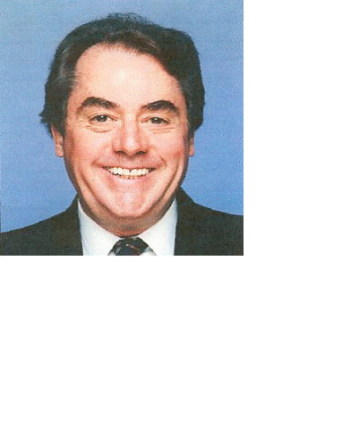• How can we build a "phalanx of professionals" around seniors to help them protect themselves from the legal and financial risks of aging?

Stephen Moses is president of the Center for Long-Term Care Reform in Seattle, WA (www.centerltc.com). The Center promotes universal access to top-quality long-term care by encouraging private financing as an alternative to Medicaid dependency for most Americans. Previously, Mr. Moses was president of the Center for Long-Term Care Financing (19982005), Director of Research for LTC, Inc., (1989-98), a senior analyst for the Inspector General of the U.S. Department of Health and Human Services (1987-89), a Medicaid state representative for the Health Care Financing Admin. (1978-87). He is widely recognized as an expert and innovator in the field of long-term care.
 Choose From: 
9:00am - 11:00am or
1:00pm - 3:00pm

US Bank Building

Idaho Insurance and CFP® CE Credits Provided

To Reserve Your Seat Call David Turner at 383-7211 or Dennis Rompala at 344-9184

Thank you to our
Thank you to our 2008 Sponsors

John Bellamy, AAPA
Vice President of Mrktng &
Annuity Marketing Director
jbellamy@unitedheritage.com
707 E. United Heritage Ct.
Meridian, ID 83642-3527
(208) 493-6100


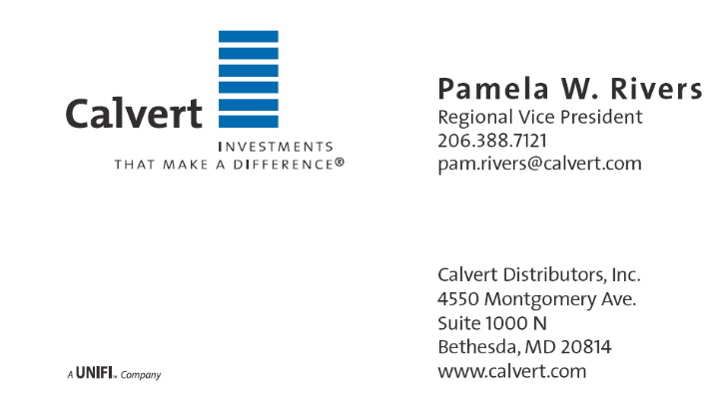

Terrie L. Trevino
Blue Cross of Idaho
Dental & Ancillary Product Manager
Phone: (208) 363-8757
Cell: (208) 695-8932
Fax: (208) 331-7582

Financial Planning Association of Idaho
5702 E Victory Rd
Nampa, ID 83687

