NEWS


Idaho News
September 2009


ase RSVP to Lacy at 468-0231 by Friday, November 12

“Investing For a Better World”

Presented by, Lisa Leff-Cooper, CFA
of Trillium Asset Management Corp.

Tuesday, September 15, 2009

The Arid Club
1137 W River St, Boise, Idaho

12:00 – 1:30 PM

Local Members – Free

Non-Members - $25

First time visitors may join us for a complimentary lunch

Please RSVP to Lacy by Friday the 11th at 468-0231 or fpaidaho@msn.com

One CFP® and One Idaho Insurance CE Credit Provided!

Idaho Chapter
2009 Board of Directors

President
Raoul Allen, CFP®
336-8445

Past President
David Turner, CFP®
US Bank Private Client Group
383-7211

President-Elect
Membership Director
Jack Thomas
AFA Financial Group, LLC
319-3618

Programs / Sponsors
Larry Halvorson, CLU, ChFC
Nexus Wealth Mgmt.
424-8080

Pro-Bono
Tom Steelman
The Helmstar Group
284-7623

Chapter Administrator
Lacy Hazel
FPAIdaho@msn.com
468-0231

Thank you to our September Sponsor:


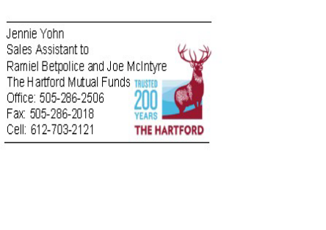

Message From the President
Raoul Allen, CFP®

Summer is quickly drawing to a close and fall fast approaching, which means our regularly scheduled luncheon meetings will resume again beginning in September. At this time I wish to extend a warm welcome back to all FPA members and I hope everyone has had an enjoyable summer able to spend some time with family or friends; otherwise, just taking some time to “recharge” the batteries. No doubt 2009 has been a very trying year for members and clients alike. The year witnessed the U.S. Economy rapidly plunge at the beginning, but there now appears to be mounting evidence of a recovery, although sustained economic growth may be painful for some time into the near future. Thus, there is the need to stay in touch with clients and remind them of their goals and objectives, closely monitoring events and altering goals if the need arises. The value of financial planning is no more evident than in times of economic stress.

September Speaker

Lisa Leff Cooper, CFA

Trillium Asset Management Corporation

Lisa is a Vice President and Portfolio Manager with Trillium Asset Management, the oldest and largest independent investment management firm devoted exclusively to socially responsible investing. Before joining Trillium in 1999, Lisa served as Director and Portfolio Manager with the Social Awareness Investment program at Smith Barney Asset Management in Manhattan. Lisa has served on the boards of the Social Investment Forum, the Idaho Conservation League; the Fund for Idaho, and Ten Thousand Villages, Boise, and currently serves on the board of the EcoLogic Development Fund. Lisa was named Idaho’s Progressive Businessperson of the Year for 2004. Lisa holds an M.B.A. from the Wharton School, and is a Chartered Financial Analyst.

Trillium Asset Management Corporation
950 W. Bannock, Suite 530
Boise, ID 83702
(800) 567-0538 ph
(208) 387-0777 ph
(208) 387-0278 fax
lleff@trilliuminvest.com

Upcoming Events:
October 3: Smart Women, Smart Money Conference. Boise Centre on the Grove. Volunteers are needed at the booth. Any amount of time is appreciated! Call 468-0231 to help.

October 20: Member Luncheon 12:00 – 1:30pm. Arid Club. John McGown, Jr., Hawley Troxell Ennis & Hawley, LLP presents, "Idaho Income Tax Issues for Trusts & Estates” CE credits provided.

October 24: Smart Women, Smart Money Conference. Coeur d’ Alene. Contact Liza Carberry at 332-2997 for sponsor info.

November 17: Member Luncheon 12:00 – 1:30pm. Arid Club. David Tate, CEO of St. Luke's Health Care System presents, "Health Care Costs" CE credits provided.

December 9: Idaho Steelheads Hockey Game. Only 40 tickets are available! RSVP required. You are invited to bring a guest and/or a person interested in the FPA Idaho.
Pro Bono Information

Foundation for Financial Planning

Helping Military Personnel & Their Families
In these times of extended and repeated deployments, our military personnel, both active and reserves, need financial empowerment more than ever. National Guard and Reserve units across the nation are being activated and deployed on a regular basis. Many deployments are disrupting personal and financial lives as many of our brave warriors are putting their careers on hold, their 401(k) and retirement savings may be interrupted, and income very often declines.
In support of these efforts, the Foundation has been providing a booklet entitled "Accomplishing Your Financial Mission" that has information and help specifically targeted to the military. A PowerPoint presentation is also available for planners in their pro bono outreach to military personnel and their families. The booklet was developed with information from FPA Pro Bono, Department of Defense and financial planners experienced with military.
Jim Peniston
Executive Director
Foundation for Financial Planning

New Members Member Anniversaries

Matt Porter 26 Years 14 Years
Securities America, Inc. Mark Roby, MS, CFP®, ChFC Mark Vehr, CFP®
Idaho Falls, Idaho Roby Financial Group Mark One Financial Planning Boise, Idaho Coeur D’ Alene, Idaho

2 Years
Scott Badger, CFP®
State Farm
Meridian, Idaho

Sponsors


John Bellamy, AAPA
Vice President of Marketing &
Annuity Marketing Director
jbellamy@unitedheritage.com
707 E. United Heritage Ct.
Meridian, ID 83642-3527
(208) 493-6100


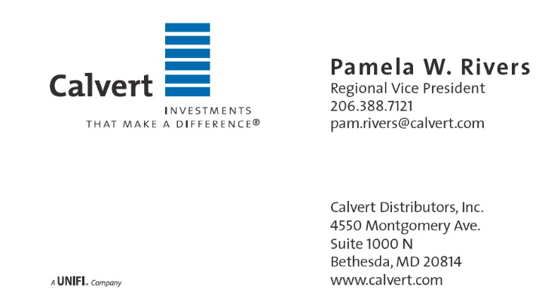



Terrie L. Trevino
Blue Cross of Idaho
Dental & Ancillary Product Manager
Phone: (208) 363-8757
Cell: (208) 695-8932
Fax: (208) 331-7582

